

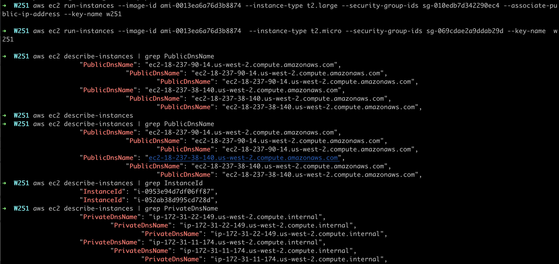

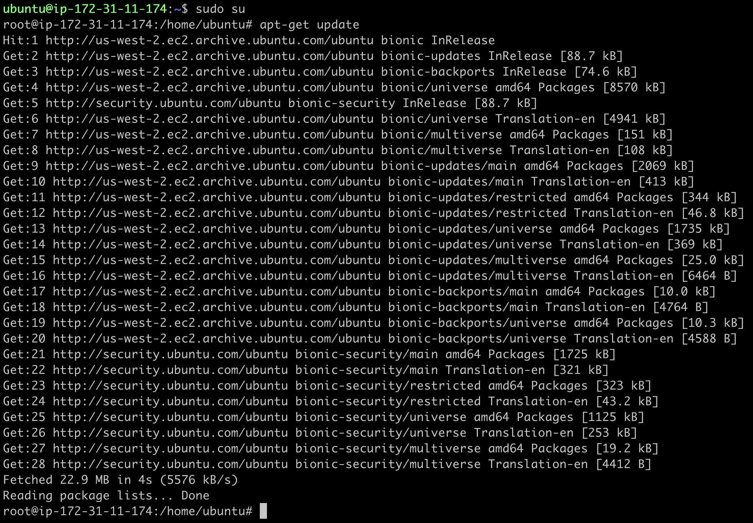

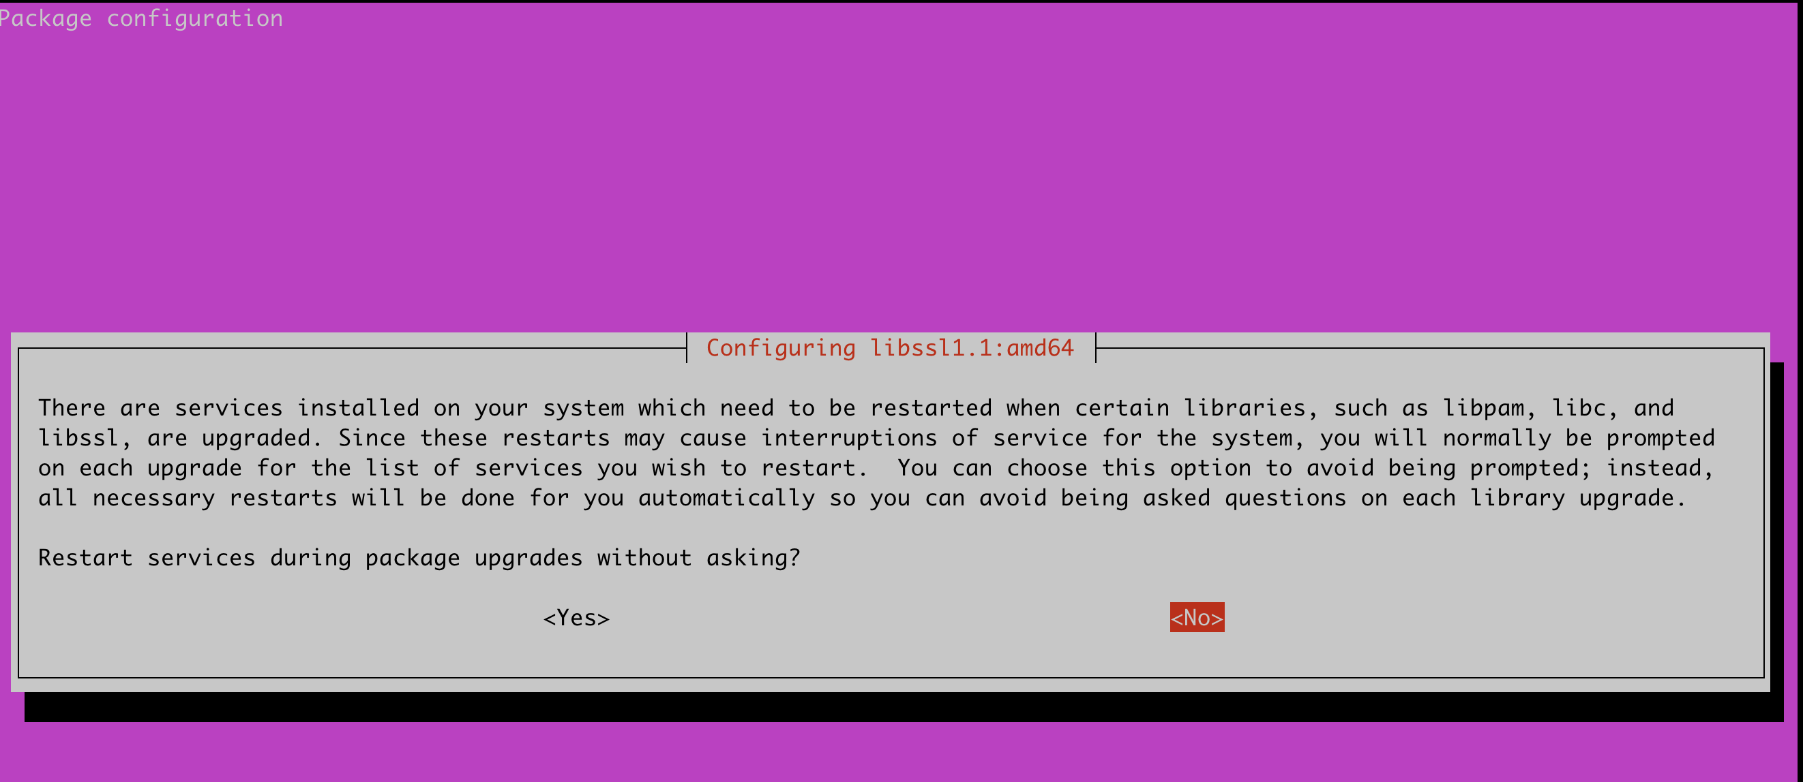

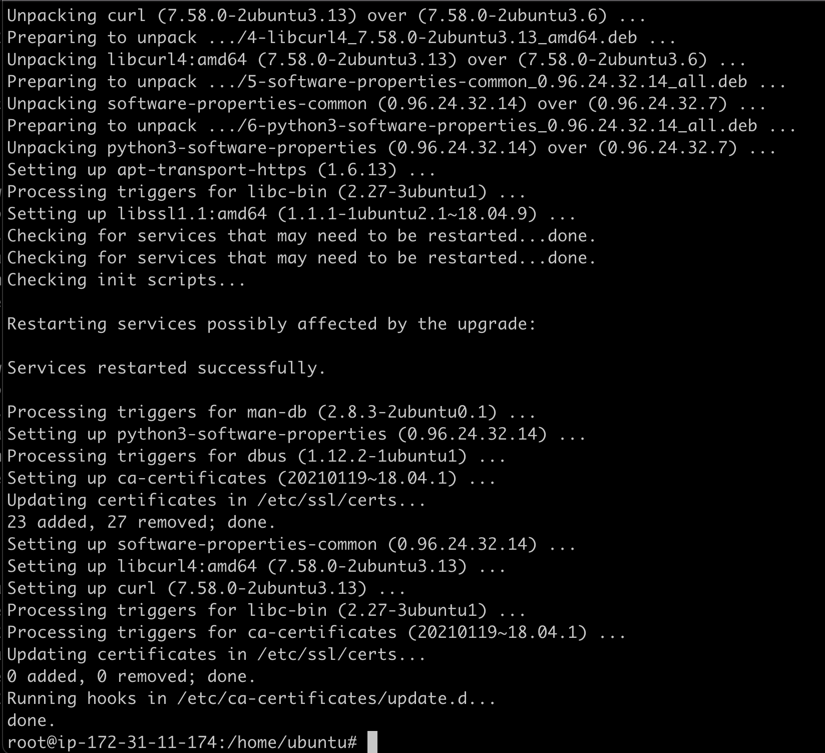

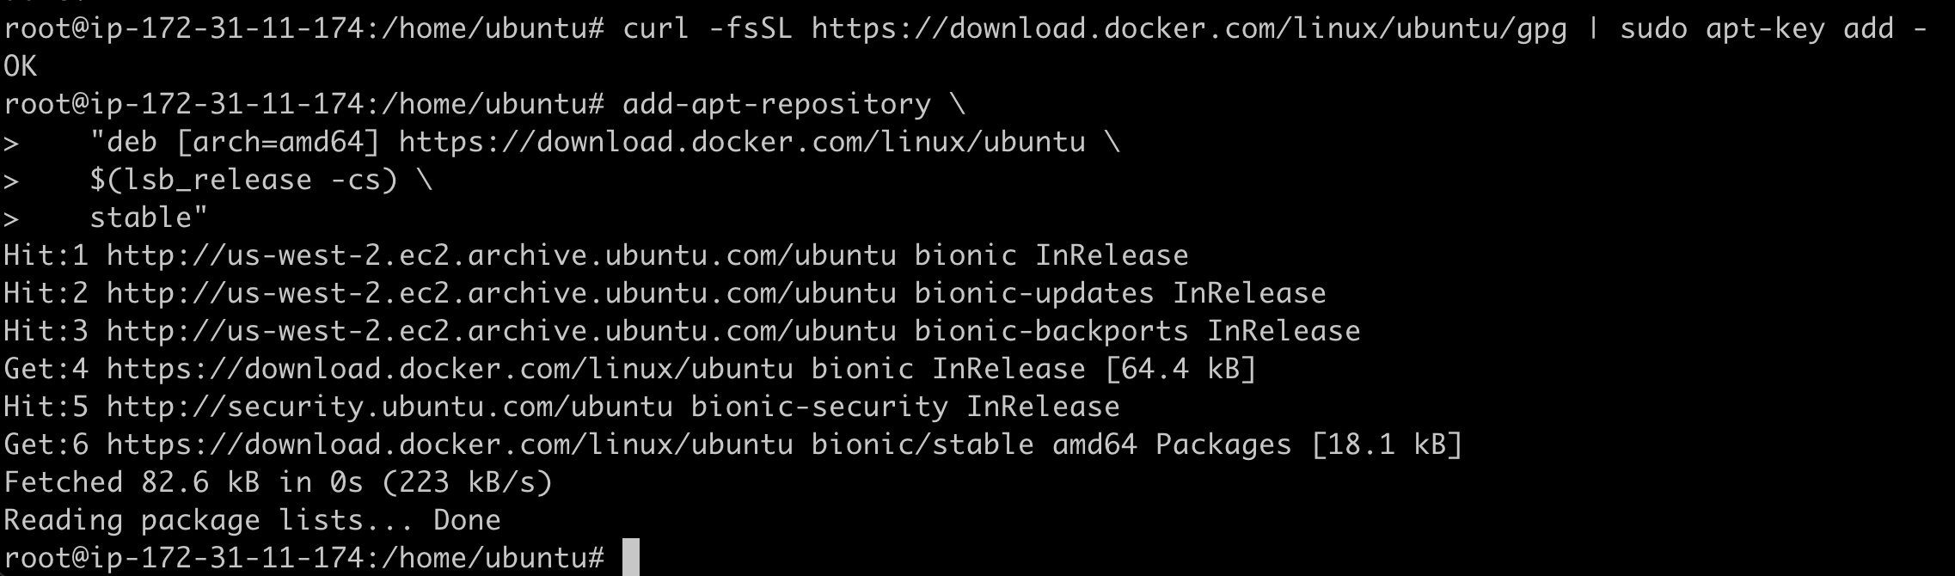

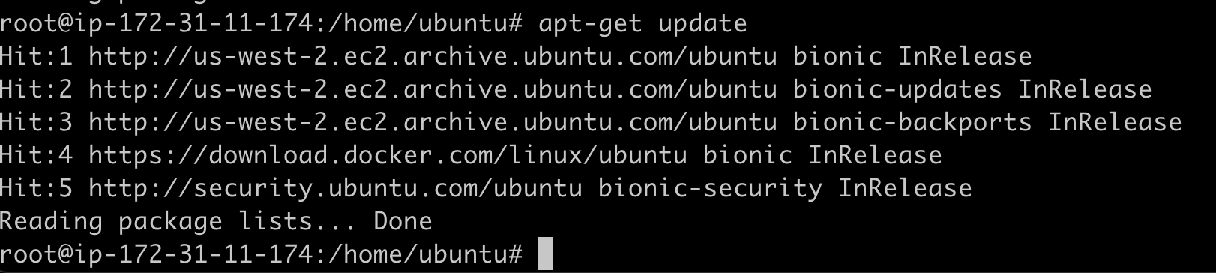

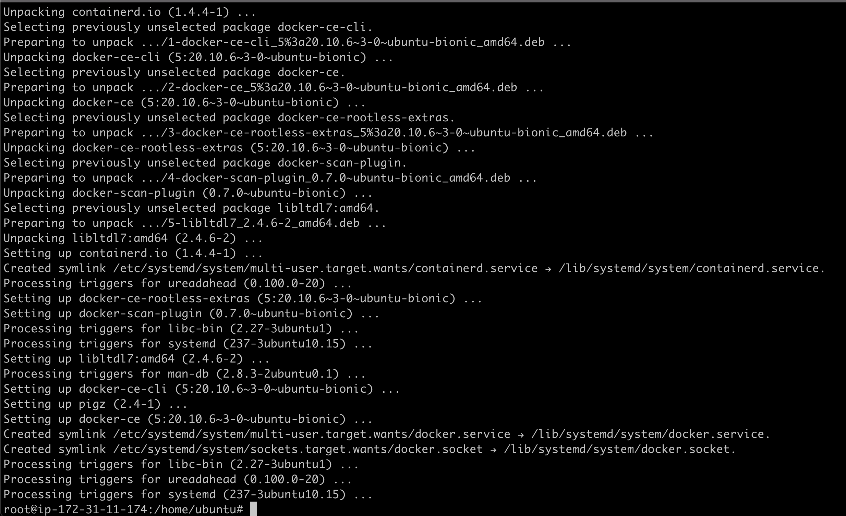

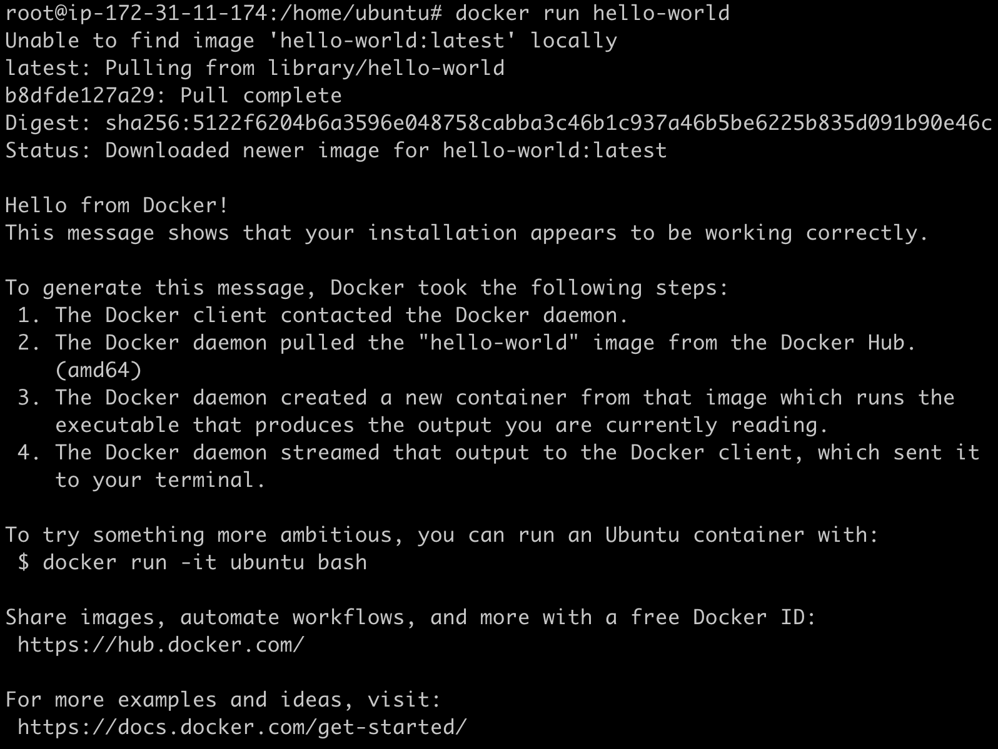

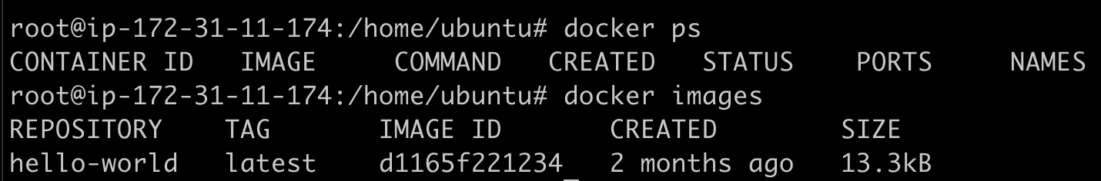

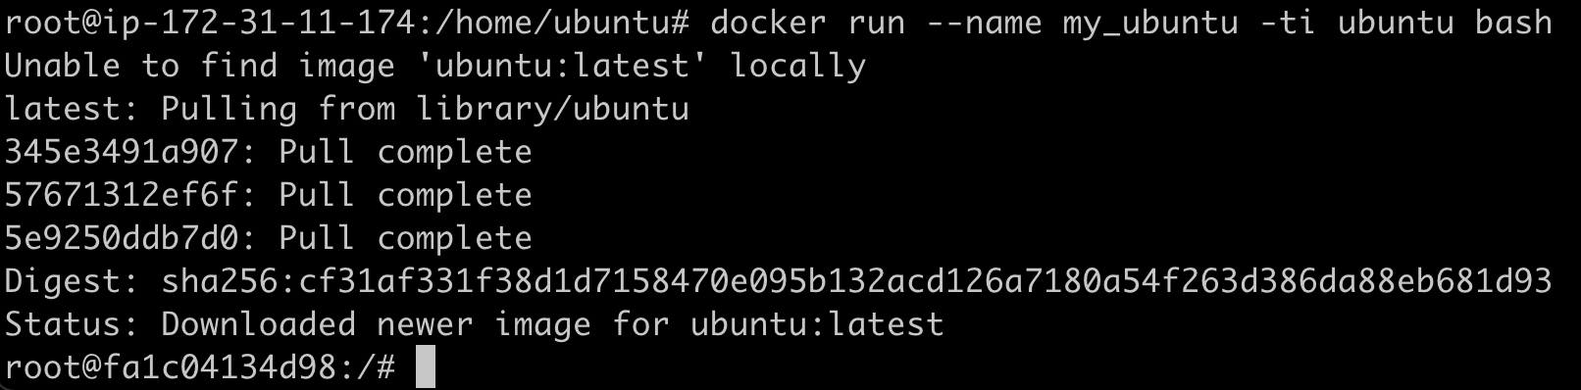

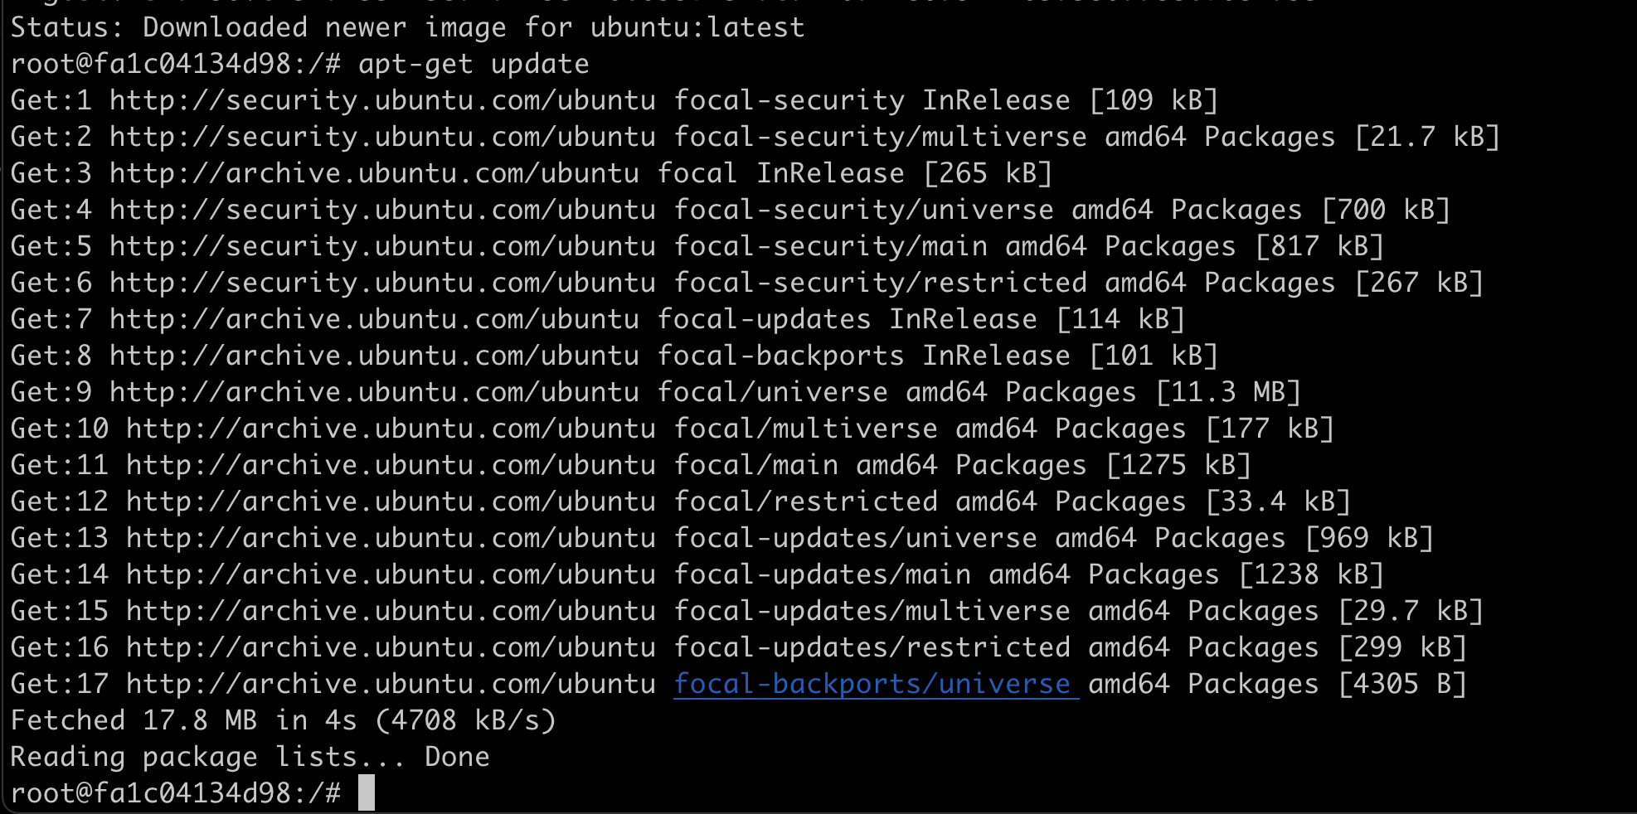

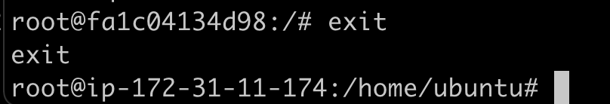

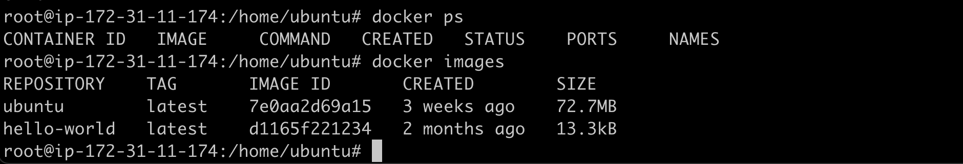

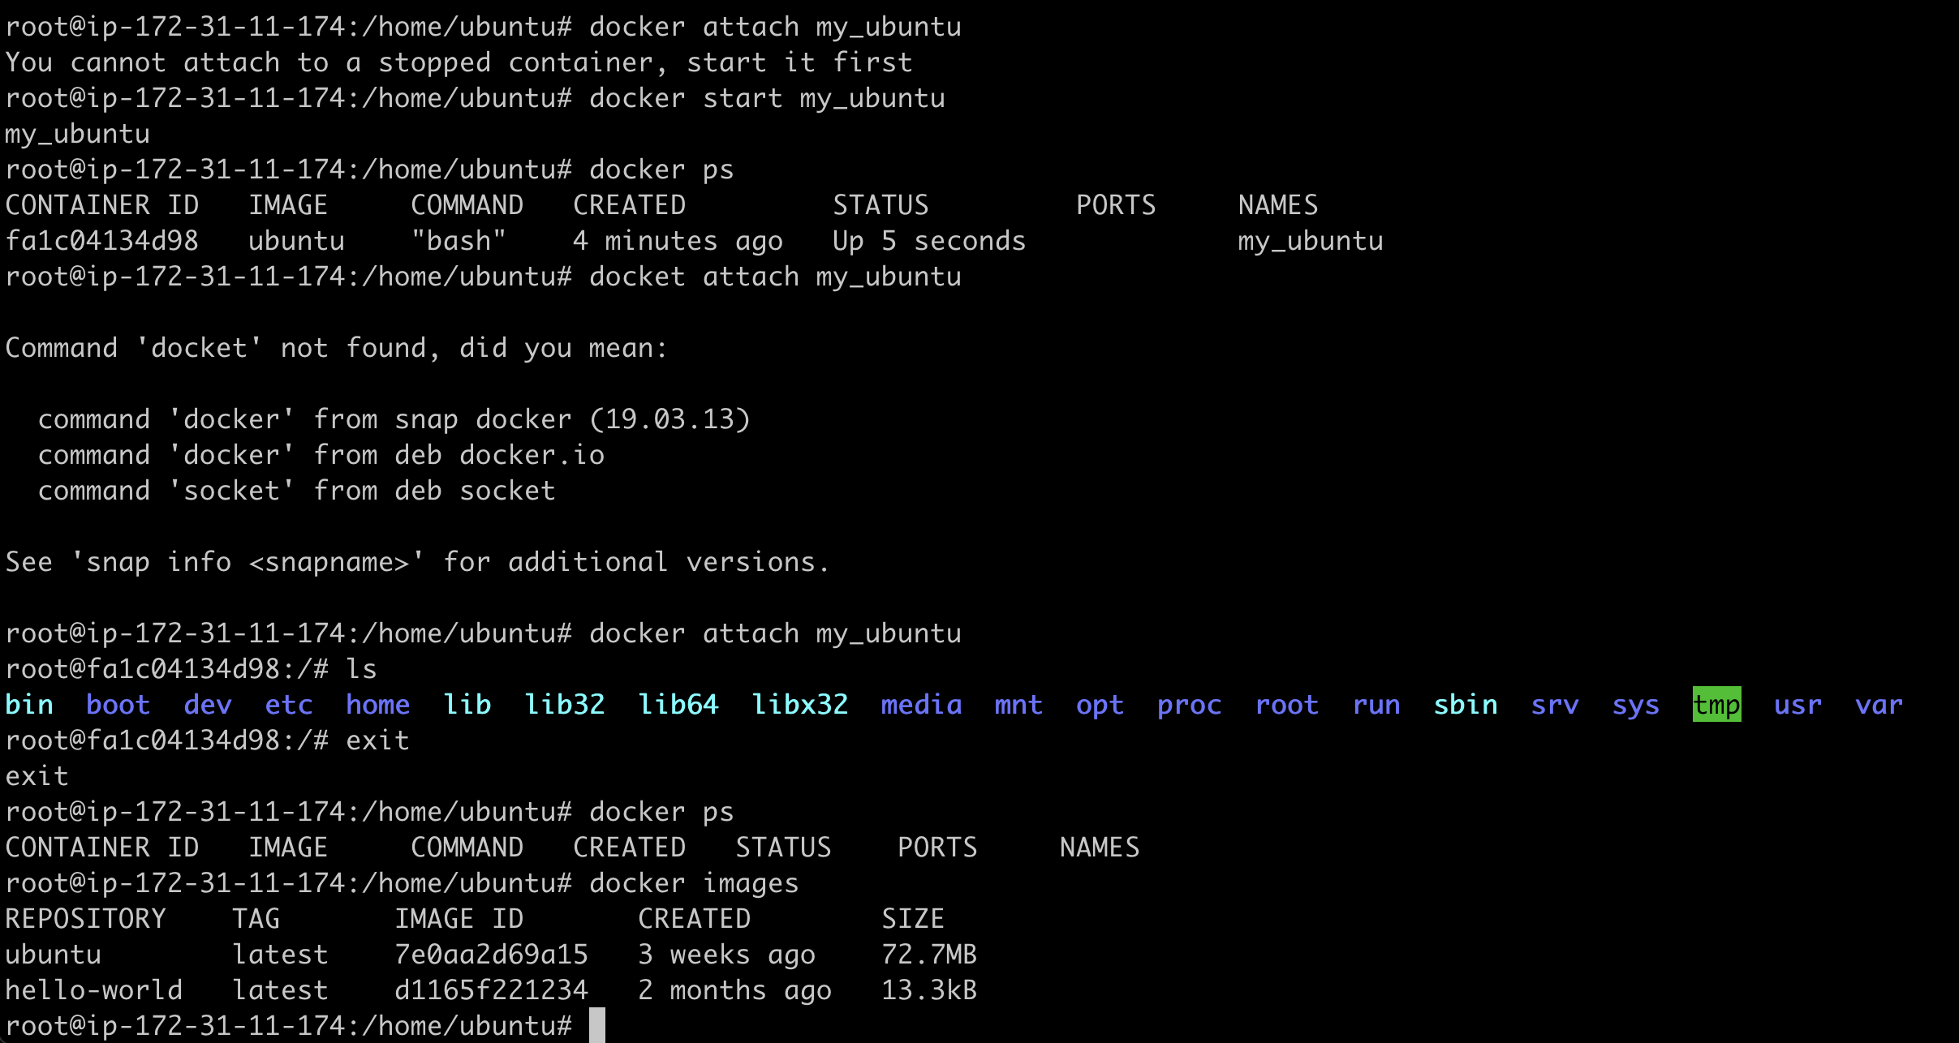

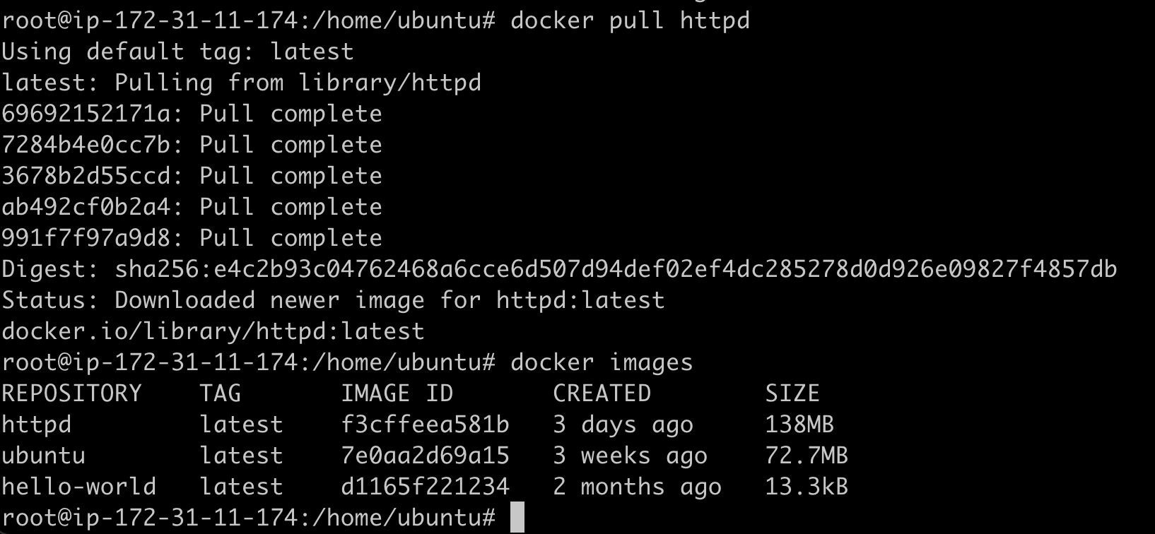

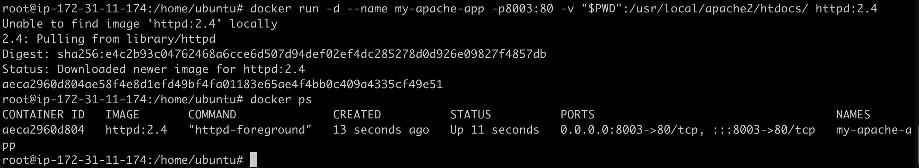



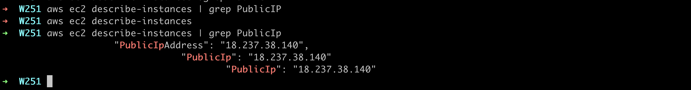

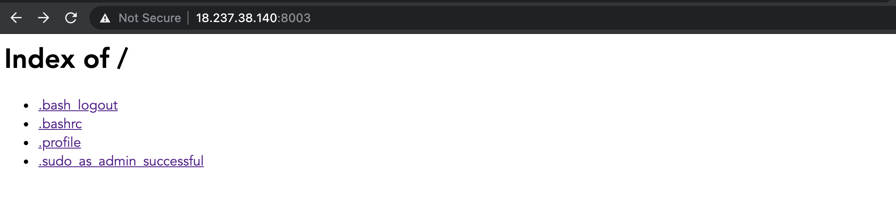

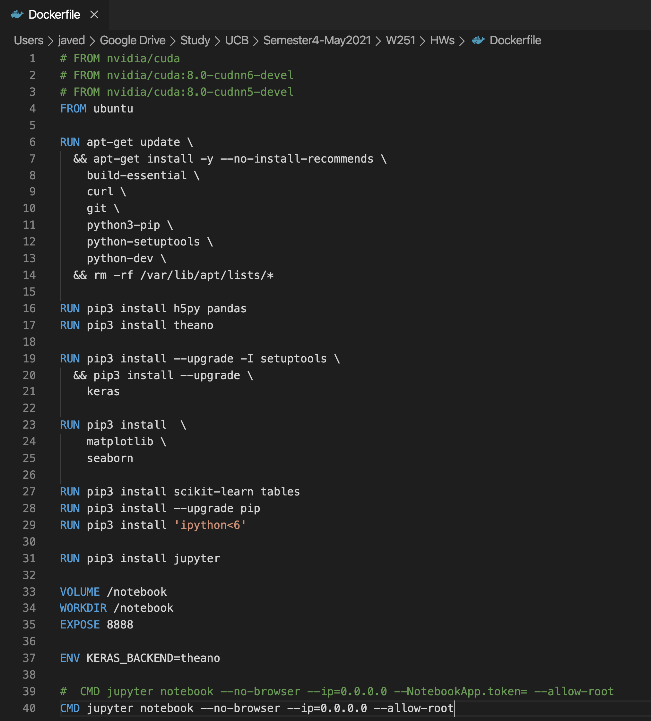

docker build -t test .

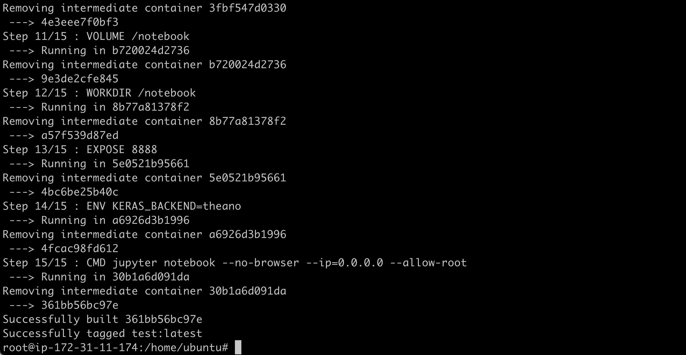

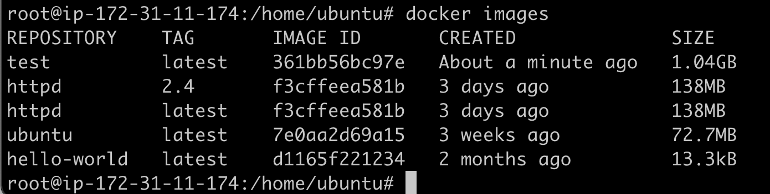

http://18.237.38.140:8800/?token=0191a3369bb6b76026d27ecd7f054186c2df503f23dcaf83

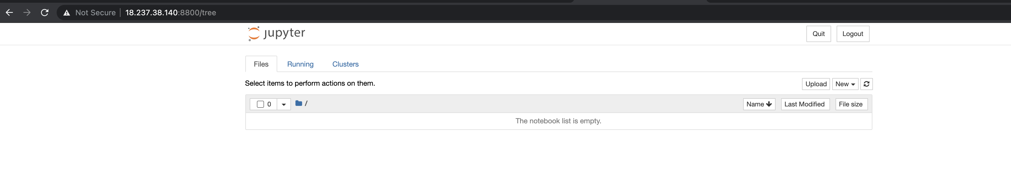

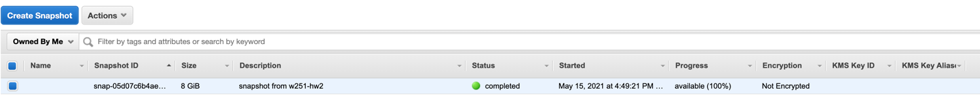

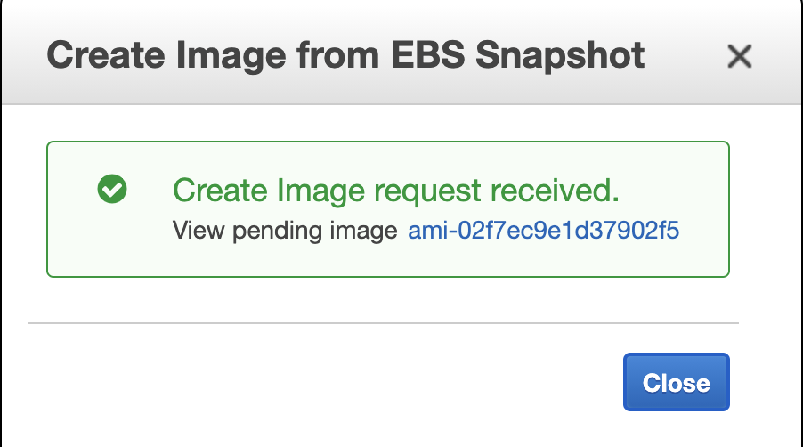



**PART-2**

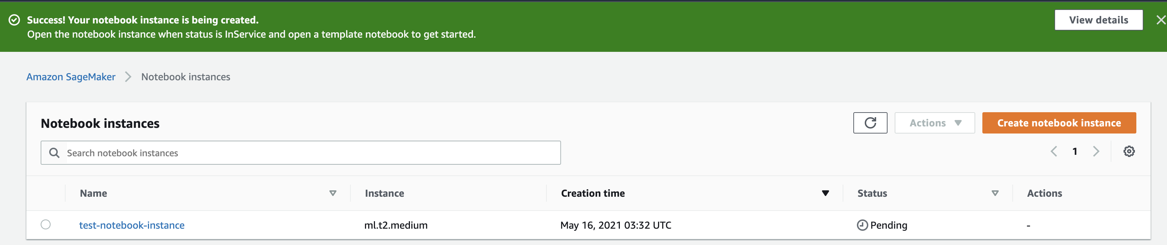

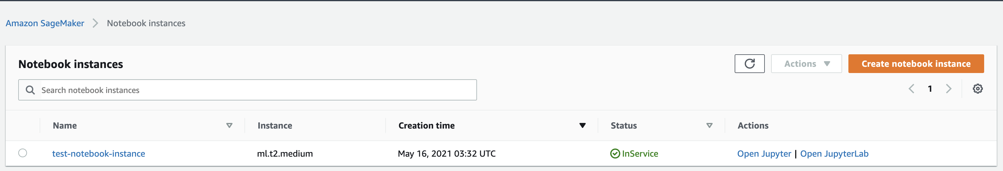

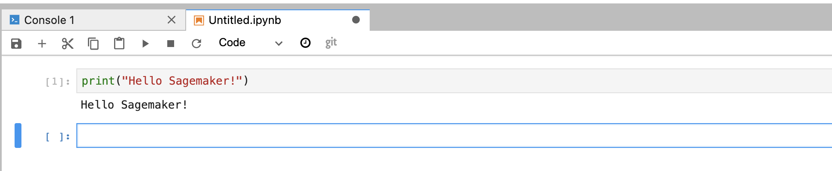

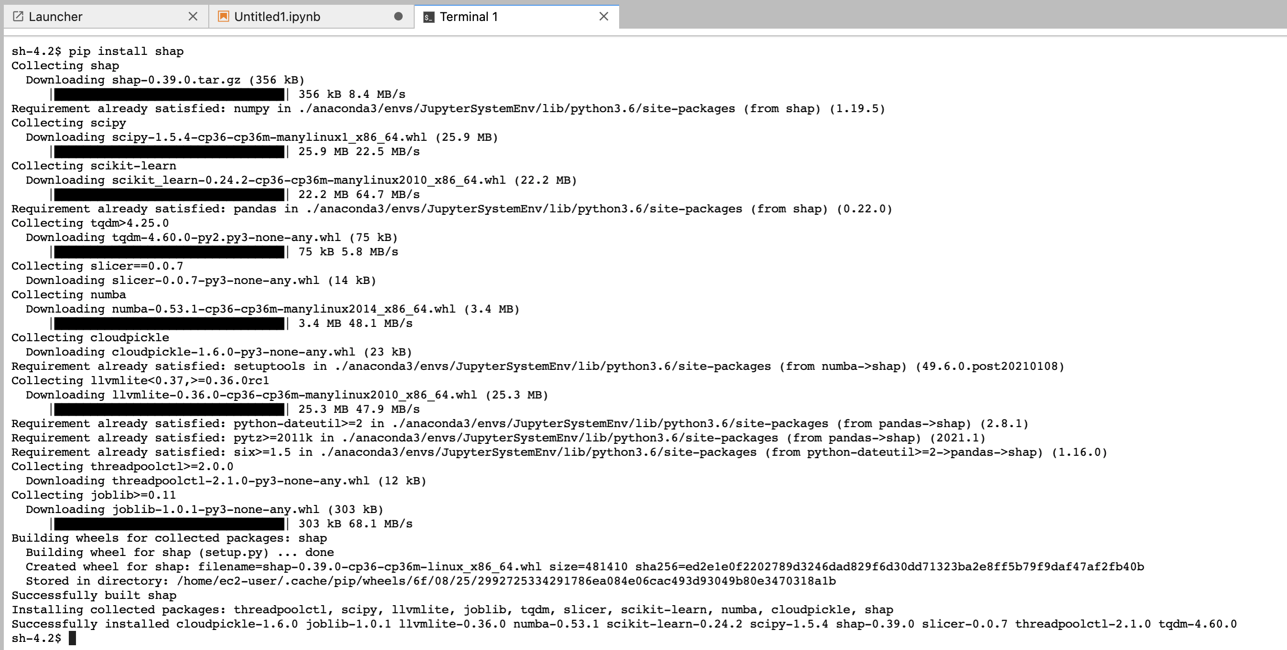

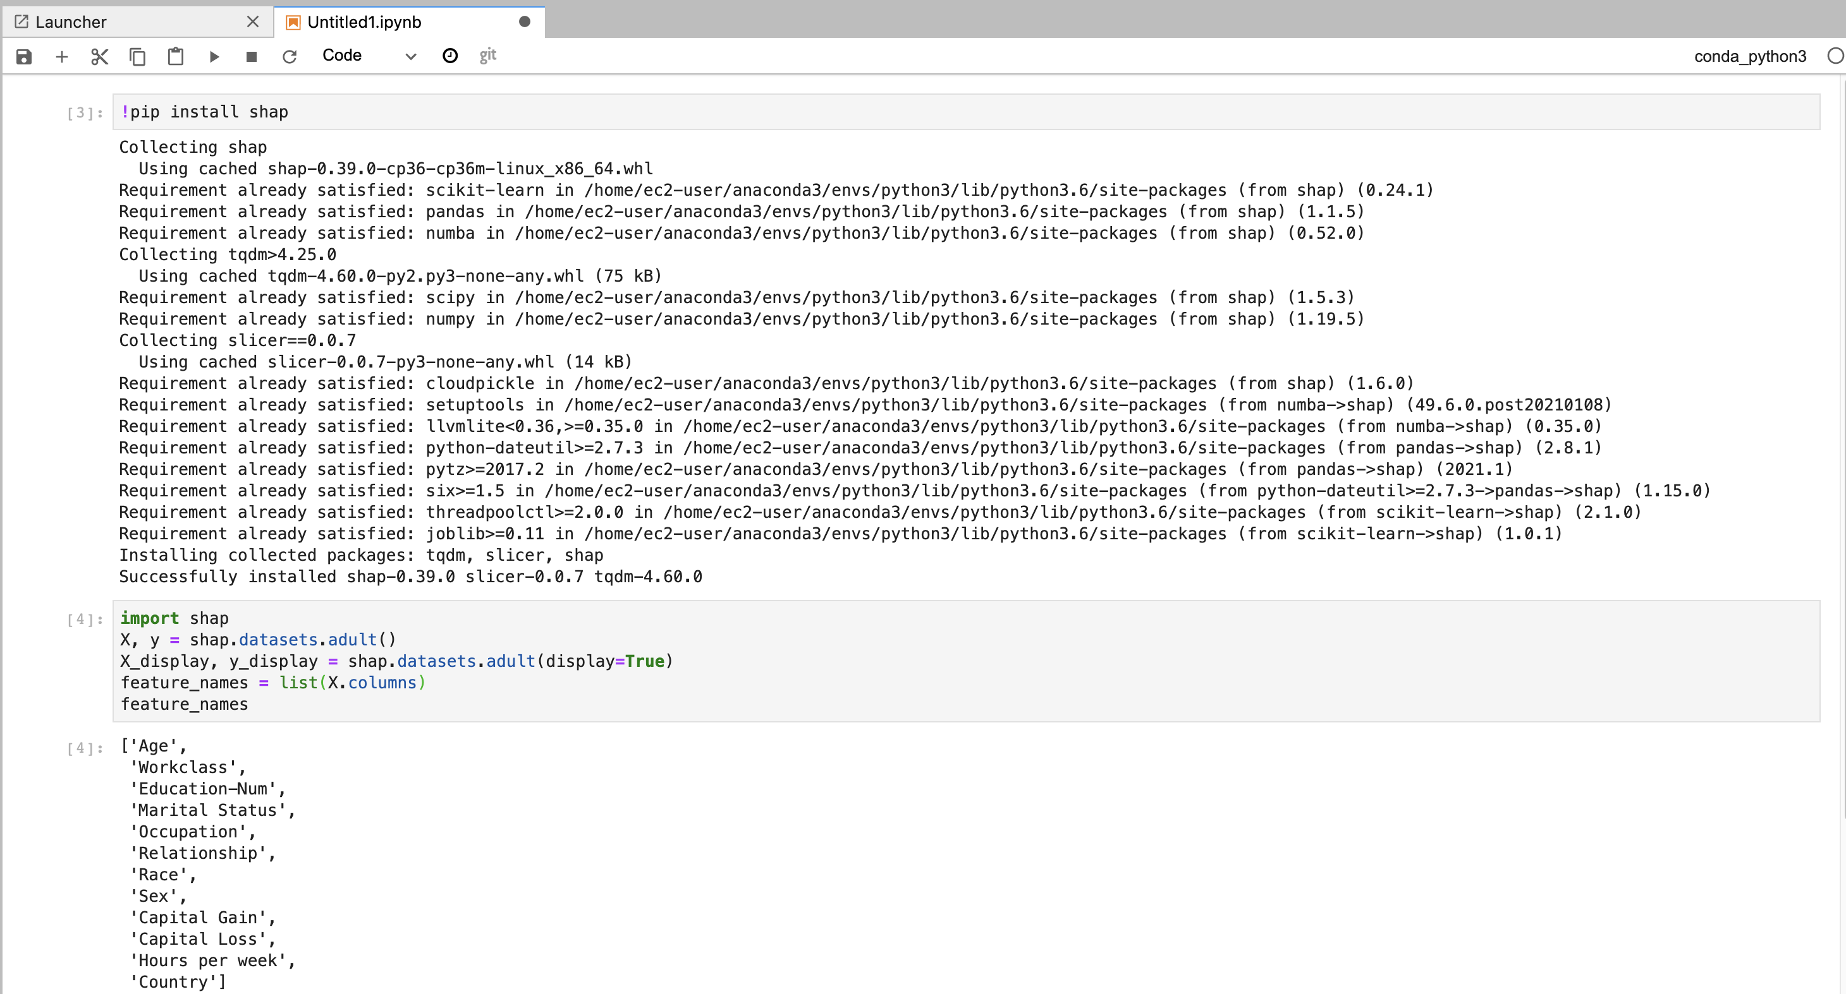

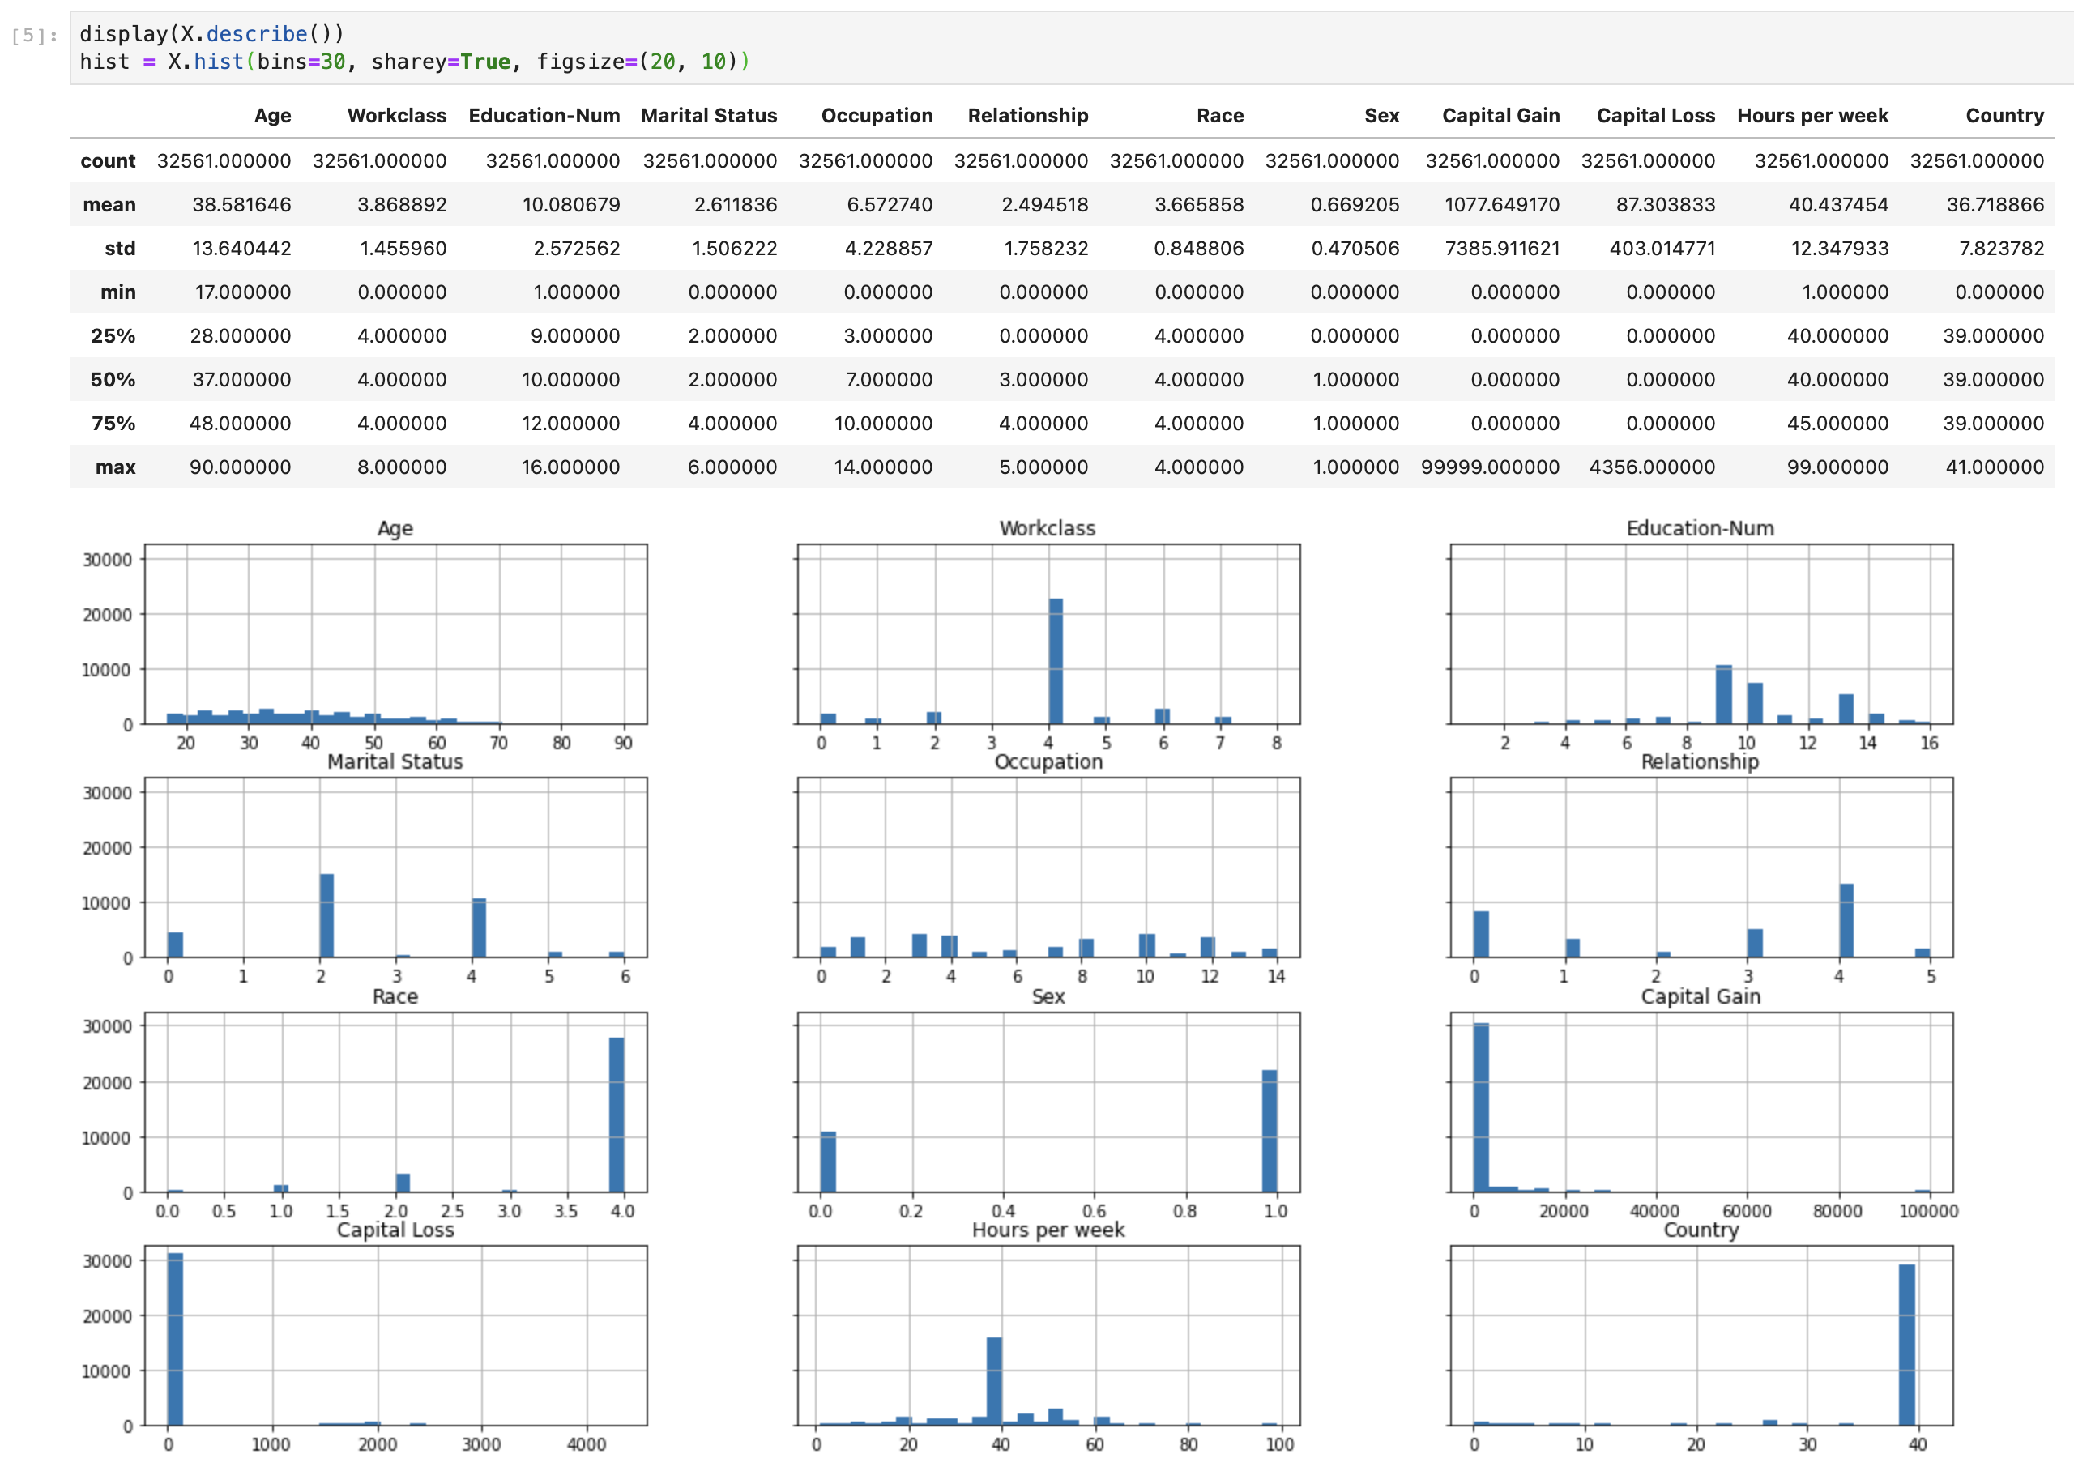

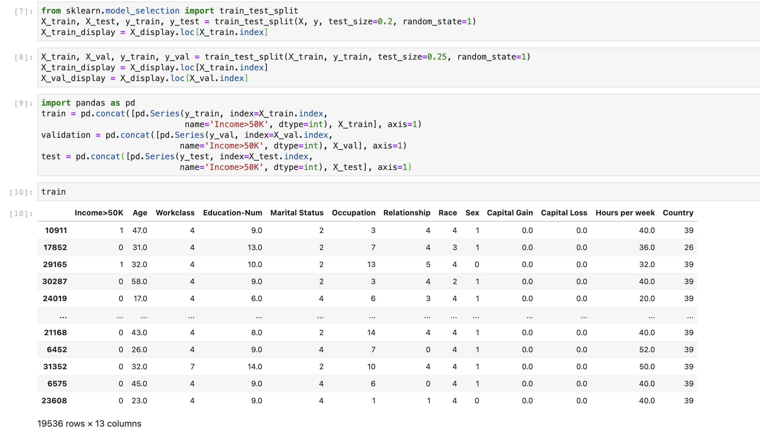

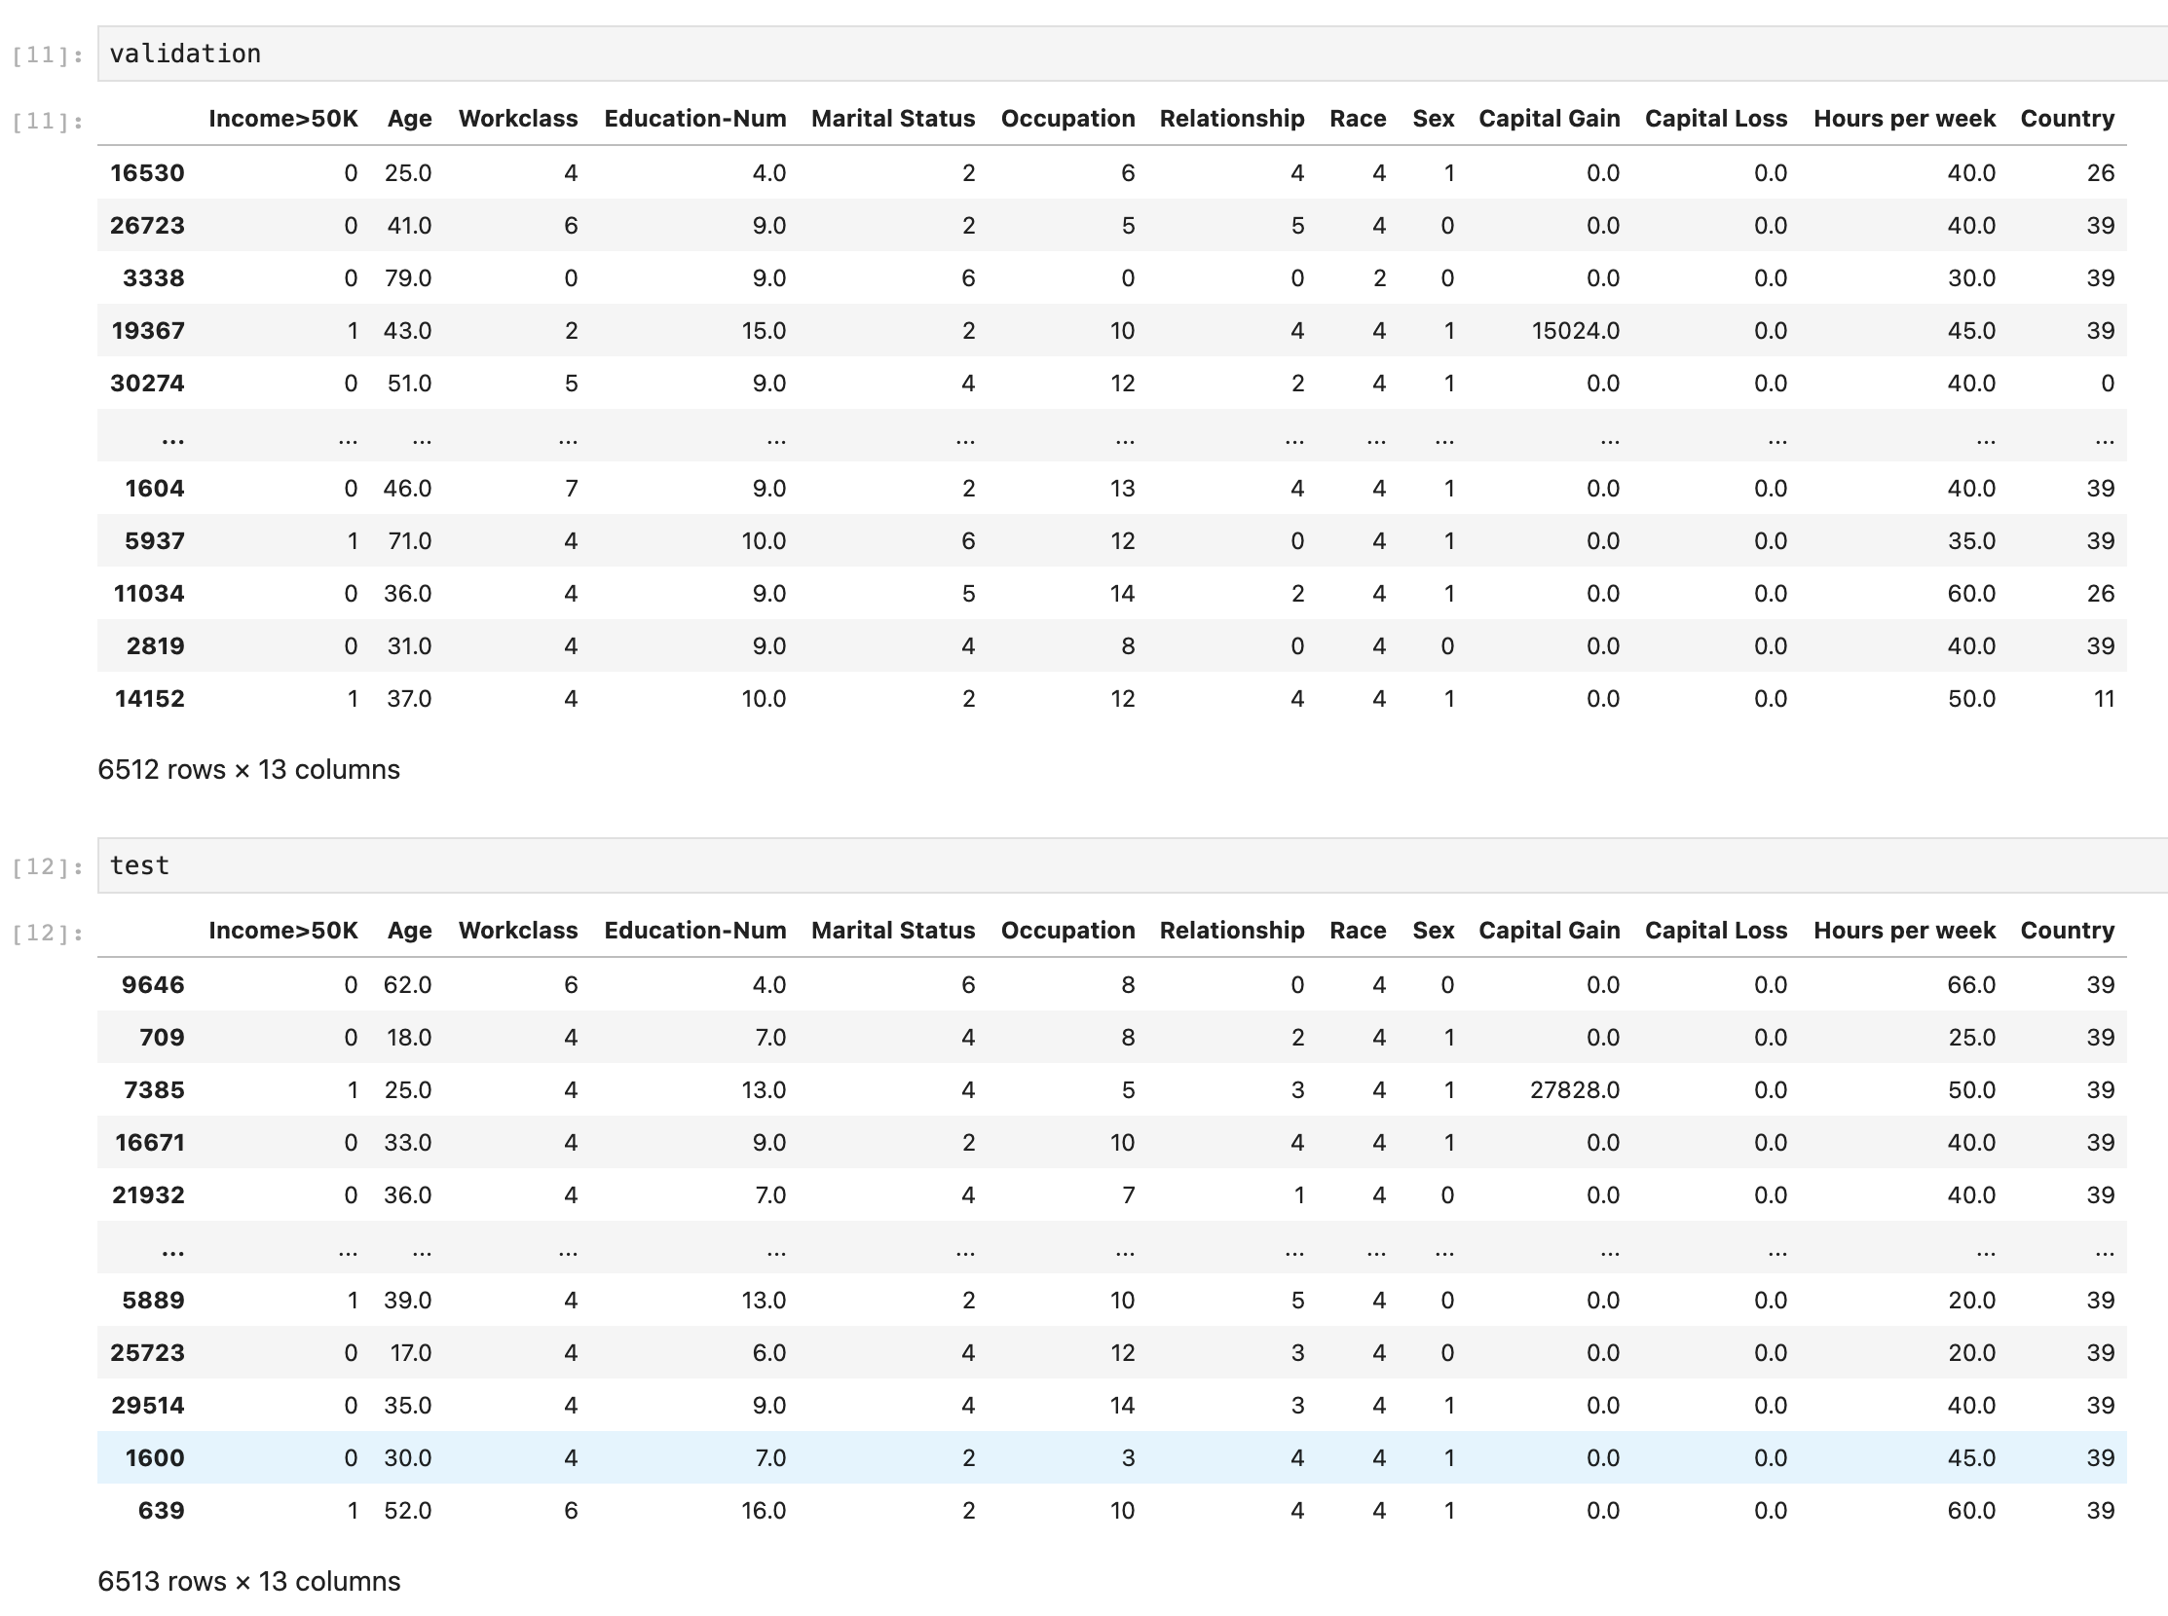

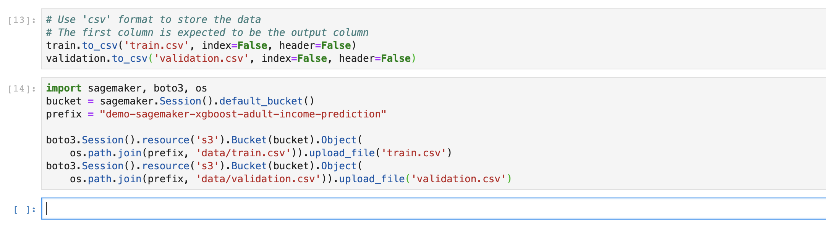



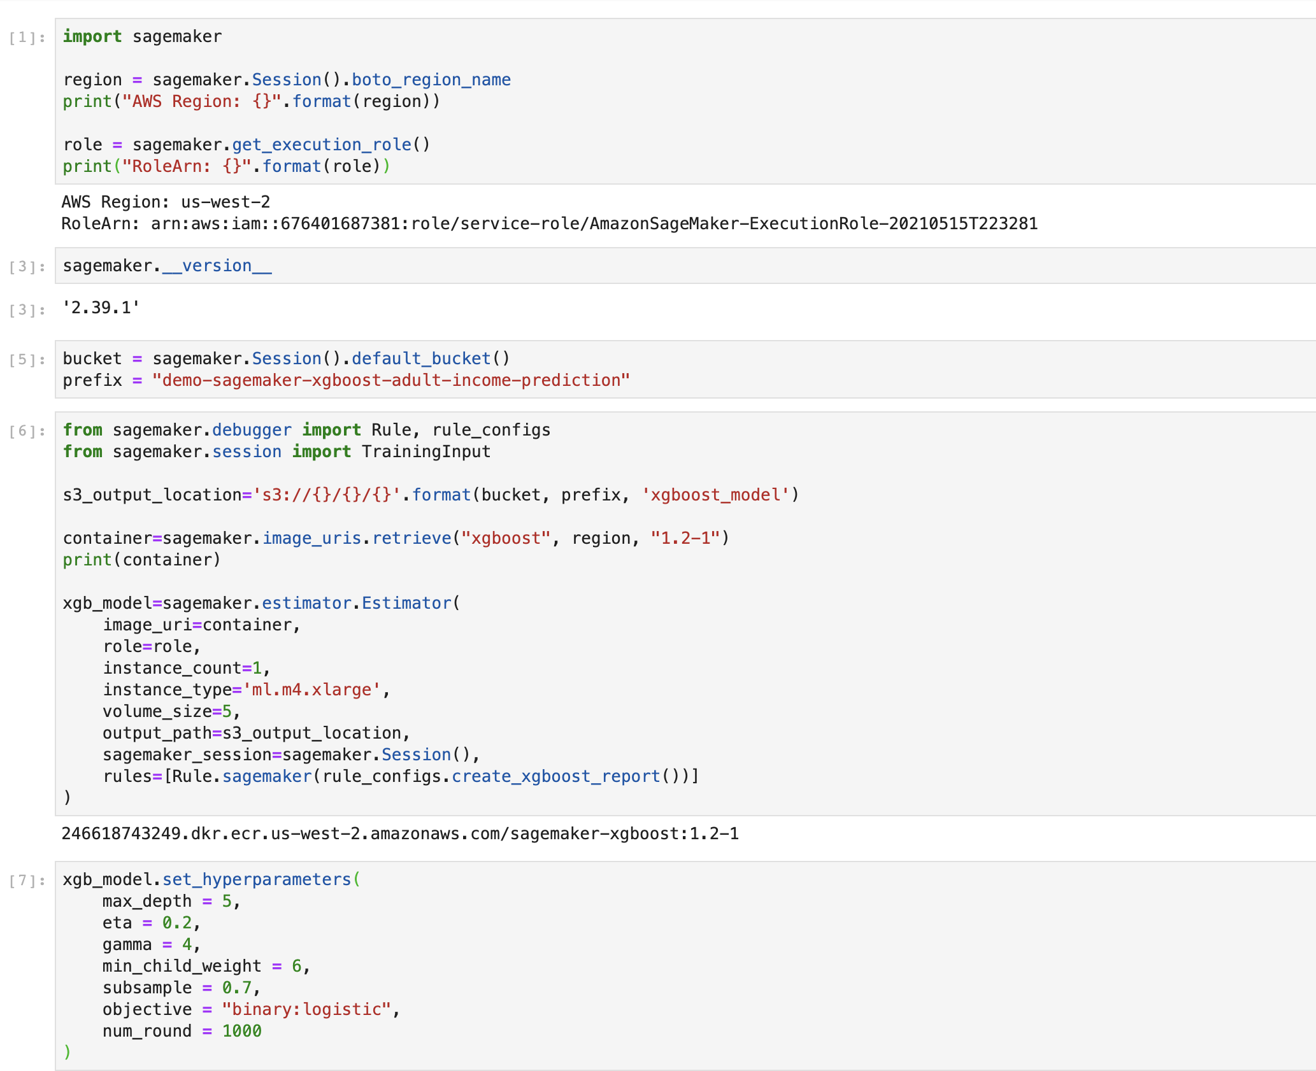

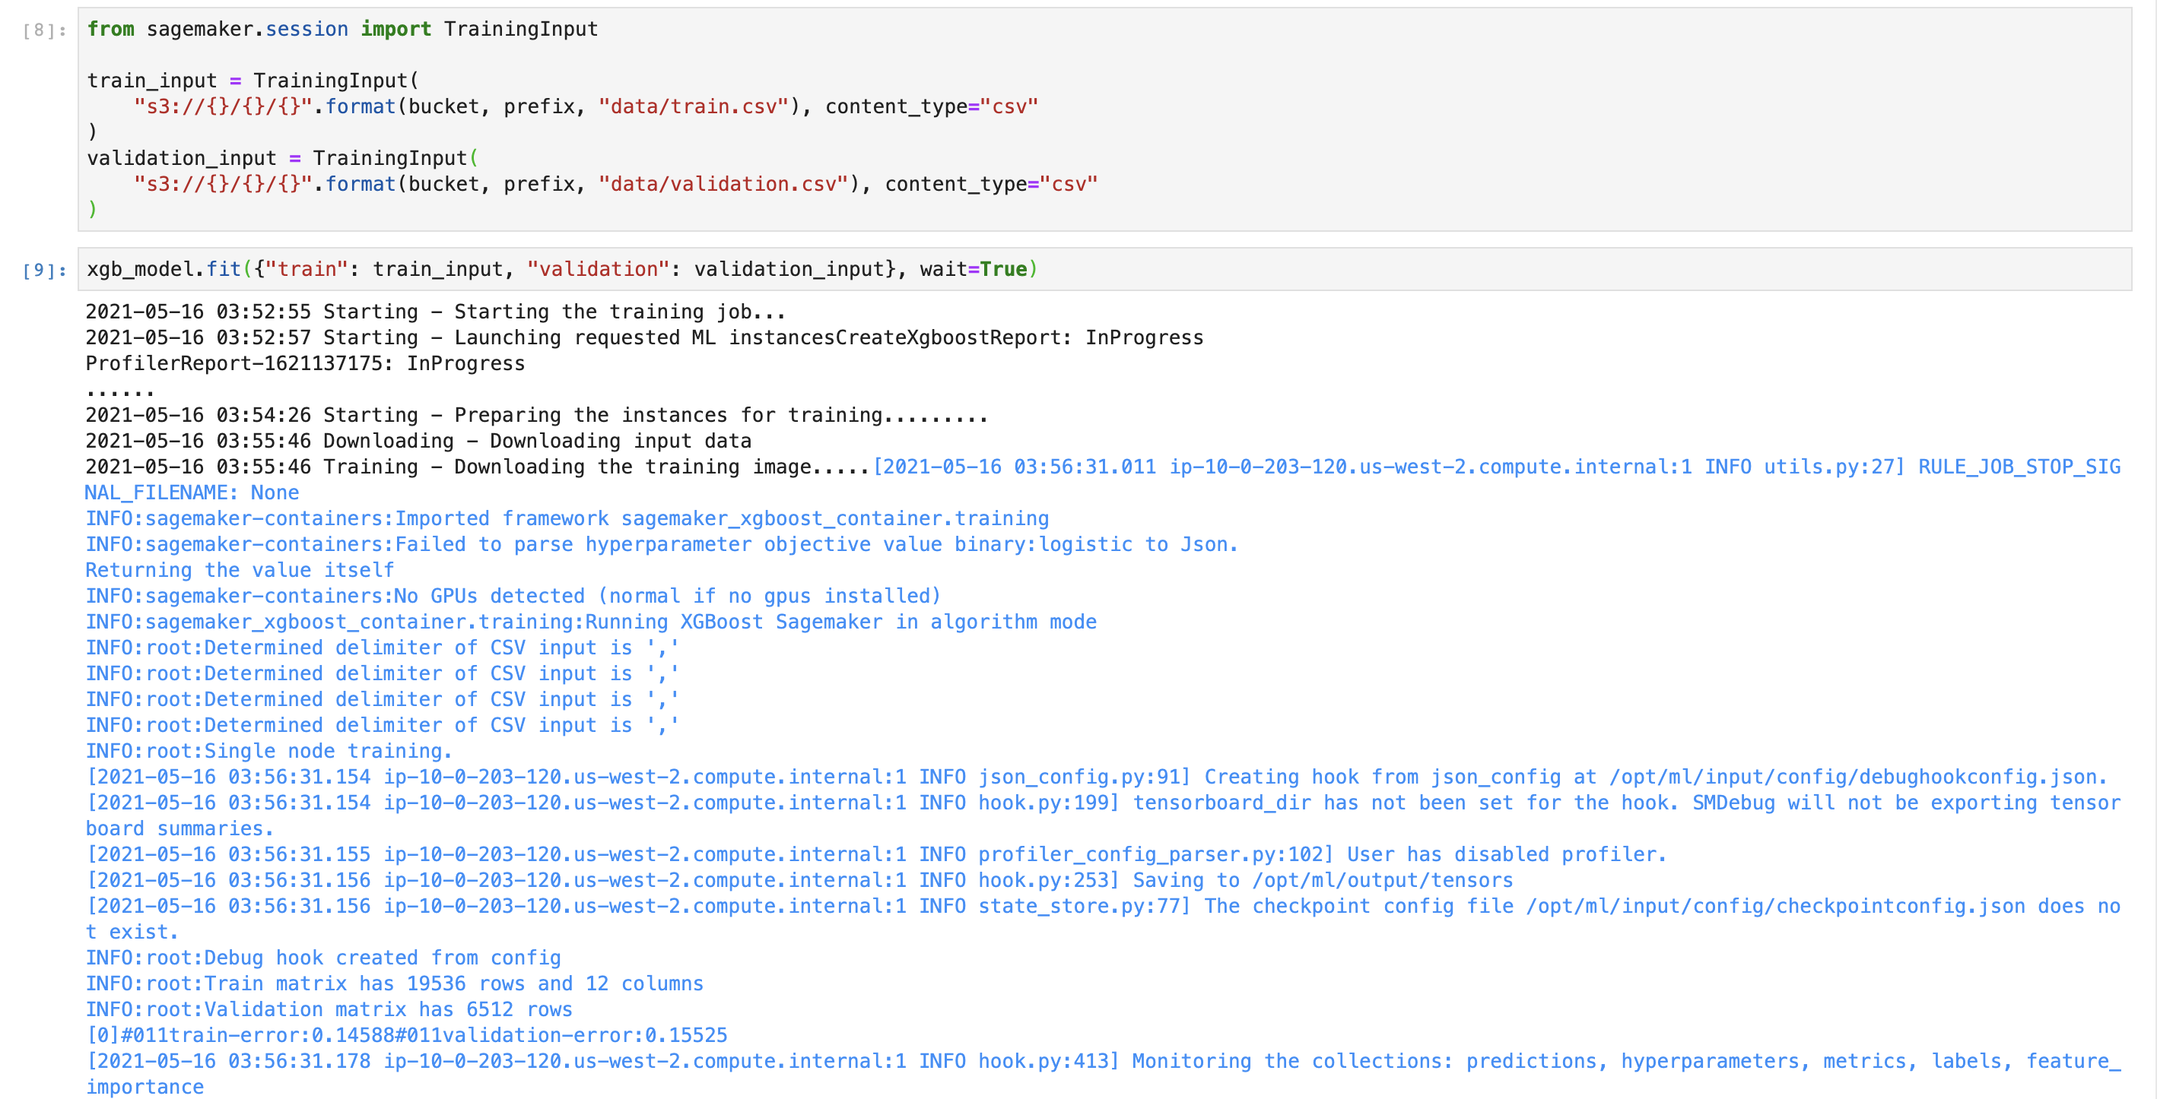

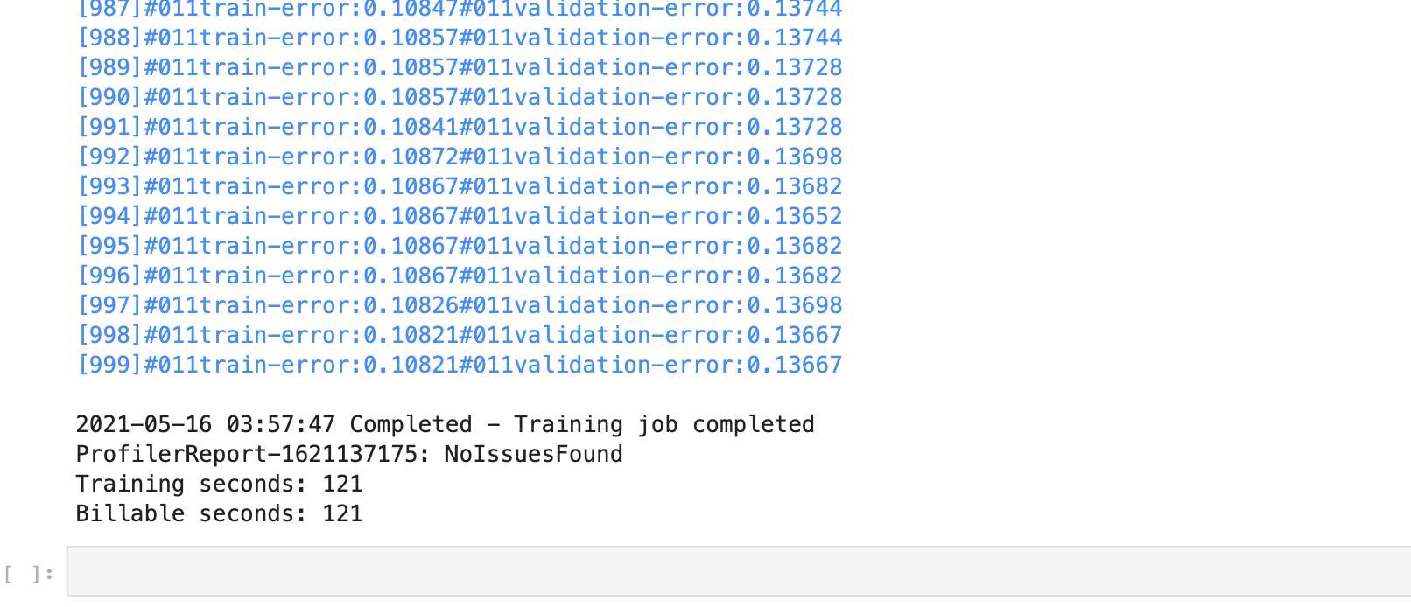

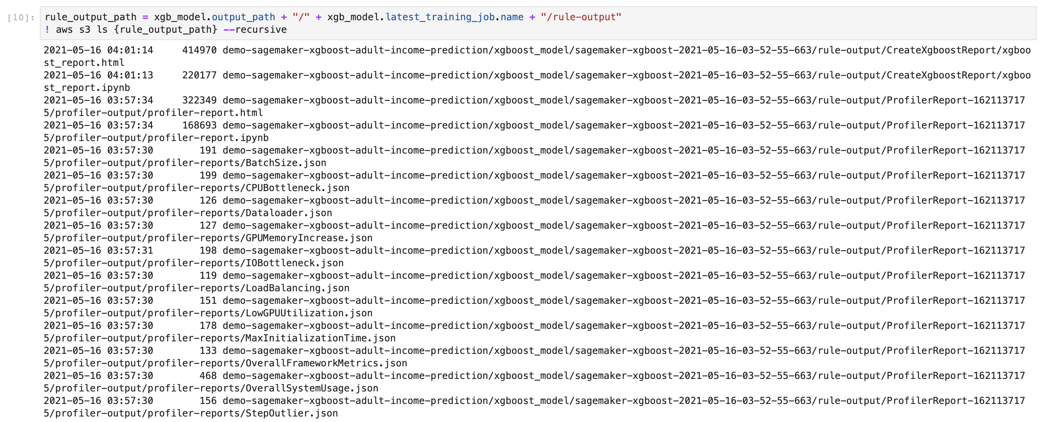

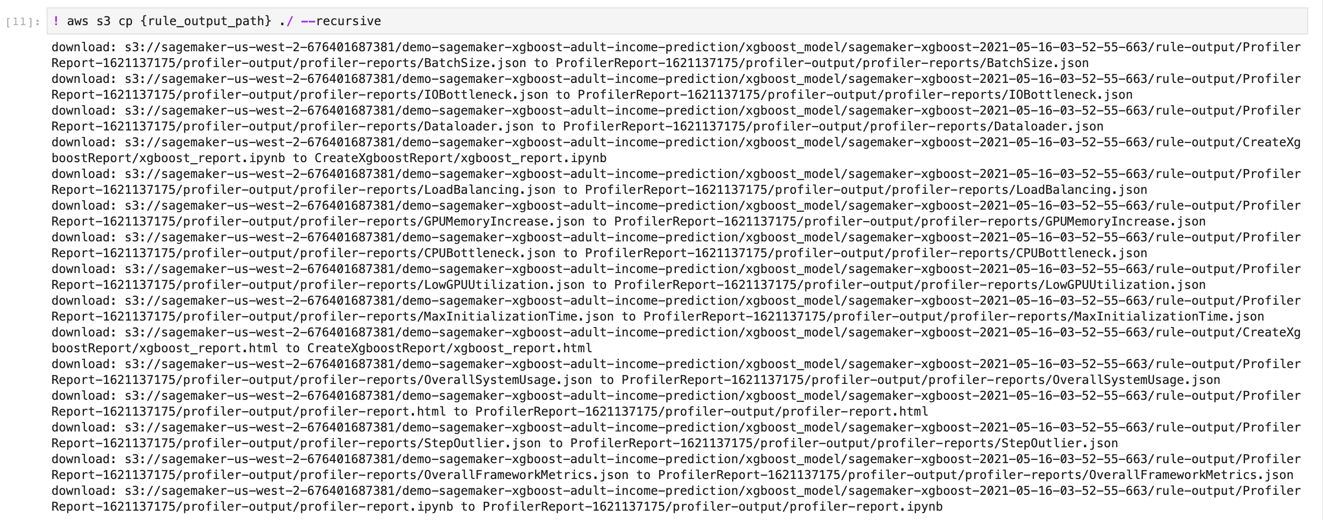

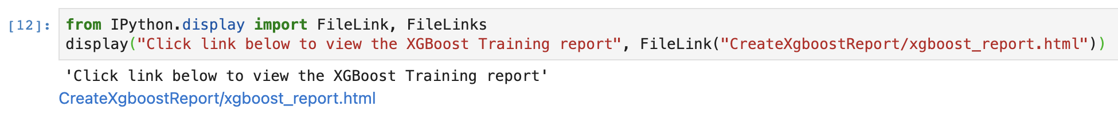

**XGBoost Training Report by SageMaker Debugger**

Created on 2021-05-16 04:00:54

The SageMaker Debugger CreateXgboostReport built-in rule auto-generates this report. This report provides a summary of the XGBoost model training evaluation results, insights of the model performance, and interactive graphs.

**Legal disclaimer:** In this report, plots and and recommendations are provided for informational purposes only and are not definitive. You are responsible for making your own independent assessment of the information. ] For more information, see the following documentation:

* [Amazon SageMaker Developer Guide](https://docs.aws.amazon.com/sagemaker/latest/dg/train-debugger.html)

If you want to use the notebook that generated this report, you need to install the following libraries:

* [SageMaker Debugger Client Library Github](https://github.com/awslabs/sagemaker-debugger)
* [The Bokeh Python Visualization Tool](http://docs.bokeh.org/en/0.11.0/docs/installation.html)

In [3]:

*# Parameters*

path = "/opt/ml/processing/input/tensors"

plot_step = 995

s3_path = "s3://sagemaker-us-west-2-676401687381/demo-sagemaker-xgboost-adult-income-prediction/xgboost_model/sagemaker-xgboost-2021-05-16-03-52-55-663/debug-output"

The following parameters are the default values auto-generated by the CreateXgboostReport built-in rule.

* path (str) - The local path where Debugger has saved output tensors in the training container.
* plot_step (int) - The step for which the rule has created the training report.
* s3_path (str) - The S3 bucket URI where Debugger has saved the output tensors.

**Table of Contents**

* [Distribution of True Labels of the Dataset](https://test-notebook-instance-ts2i.notebook.us-west-2.sagemaker.aws/files/CreateXgboostReport/xgboost_report.html?_xsrf=xsrf-token-set-by-sagemaker-1621137846642#section1)
* [Loss vs Step Graph](https://test-notebook-instance-ts2i.notebook.us-west-2.sagemaker.aws/files/CreateXgboostReport/xgboost_report.html?_xsrf=xsrf-token-set-by-sagemaker-1621137846642#section2)
* [Feature Importance](https://test-notebook-instance-ts2i.notebook.us-west-2.sagemaker.aws/files/CreateXgboostReport/xgboost_report.html?_xsrf=xsrf-token-set-by-sagemaker-1621137846642#section3)
* [Confusion Matrix](https://test-notebook-instance-ts2i.notebook.us-west-2.sagemaker.aws/files/CreateXgboostReport/xgboost_report.html?_xsrf=xsrf-token-set-by-sagemaker-1621137846642#section4)
* [Evaluation of the Confusion Matrix](https://test-notebook-instance-ts2i.notebook.us-west-2.sagemaker.aws/files/CreateXgboostReport/xgboost_report.html?_xsrf=xsrf-token-set-by-sagemaker-1621137846642#section4-1)
* [Accuracy Rate of Each Diagonal Element over Iteration](https://test-notebook-instance-ts2i.notebook.us-west-2.sagemaker.aws/files/CreateXgboostReport/xgboost_report.html?_xsrf=xsrf-token-set-by-sagemaker-1621137846642#section4-2)
* [Receiver Operating Characteristic Curve](https://test-notebook-instance-ts2i.notebook.us-west-2.sagemaker.aws/files/CreateXgboostReport/xgboost_report.html?_xsrf=xsrf-token-set-by-sagemaker-1621137846642#section5)
* [Distribution of Residuals at Last Saved Step](https://test-notebook-instance-ts2i.notebook.us-west-2.sagemaker.aws/files/CreateXgboostReport/xgboost_report.html?_xsrf=xsrf-token-set-by-sagemaker-1621137846642#section6)

Loading BokehJS ...

**Distribution of True Labels of the Dataset**

In the following graph, you can check the histogram of the true (target) labels of your raw data. You can see if the distribution of the target labels for prediction are skewed (in case of regression) or imbalanced (in case of classification).

* If the data for regression is skewed, you might want to reduce the skewness by taking the log or power transformation on the right-scewed or the left-scewed data respectively. Using the Python [NumPy](https://numpy.org/) library, you can simply apply [numpy.log](https://numpy.org/doc/stable/reference/generated/numpy.log.html?highlight=log#numpy.log) or [numpy.exp](https://numpy.org/doc/stable/reference/generated/numpy.exp.html?highlight=exp" \l "numpy.exp) to your target values.
* If the data for classification is imbalanced, you might want to improve your sample by collecting more data, resampling, or generating synthetic samples. This can also be mitigated at the step of evaluating performance metrics, such as Confusion Matrix, Precision, Recall, F-score, and Receiver Operating Characteristic curves.

**Loss vs Step Graph**

SageMaker Debugger automatically captures loss values of the [XGBoost Learning Task Parameters](https://xgboost.readthedocs.io/en/latest/parameter.html" \l "learning-task-parameters).

The loss curves provide the following insights.

* An **underfitting** model *(high bias)* has high training error and high validation error. Underfitting means that your model is not converging while training, resulting in a generalization failure on both training and validation data sets.
* An **overfitting** model *(high variance)* has extremely low training error but a high validation error. Overfitting happens when your model is trained too well to fit the noisy training data, resulting in negative impacts on your model performance on validation set.

**Suggestions**:

* If underfitting, the model is not suitable to your dataset, or the model parameters are not properly set up. You might want to consider:
  + adding more features
  + increasing the complexity of your model — increase the depth of each tree, max_depth
  + tuning the hyperparameters — decrease the gamma and eta parameters
  + decreasing regularization parameters — the lambda and alpha parameters
  + or even training and comparing with other algorithms.
* If overfitting, the model is too complex and trains to fit on the noisiness of the training set. You might want to consider:
  + reducing the depth of each tree, max_depth
  + increasing the min_child_weight parameter
  + tuning the hyperparameters — increase the gamma and eta parameters
  + increasing regularization parameters — the lambda and alpha parameters
  + increasing the subsample and colsample_bytree parameters
  + pruning a tree to remove the least significant feature — referring to the next sections where the feature importance scores are provided.

**Feature Importance**

Feature importance refers to techniques that assign scores to input features based on how useful they are at predicting a target variable. The supported importance types for XGBoost are:

* **Weight** (or **Frequency**) is the percentage representing the relative number of times a particular feature occurs in the trees of the model.
* **Gain** is the improvement in accuracy brought by a feature to the branches it is on. *The Gain is the most relevant attribute to interpret the relative importance of each feature.*
* **Coverage** measures the relative quantity of observations concerned by a feature.

**Confusion Matrix**

The following Confusion Matrix shows a breakdown of the classification results.

* The cells on the principal diagonal shows the True Positive counts.
* The off-diagonal cells count the number of misclassified predictions.

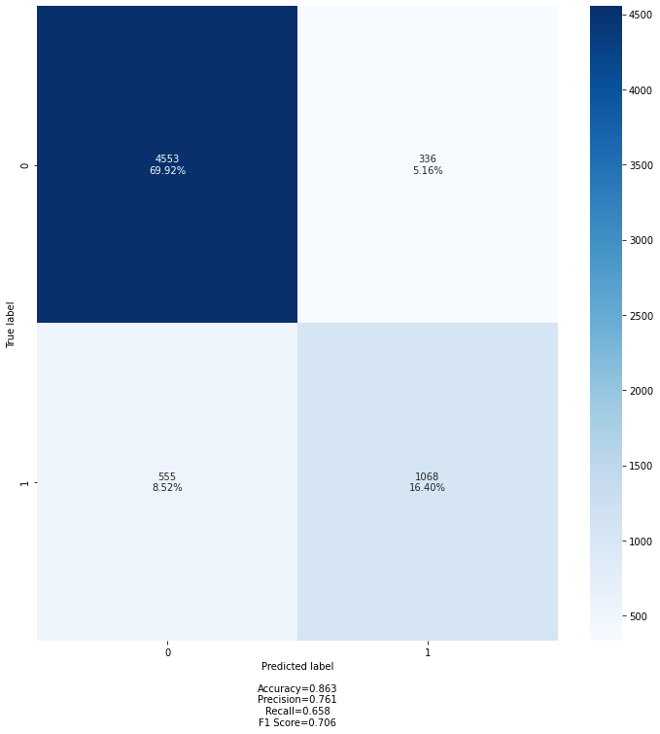

**Evaluation of the Confusion Matrix**

The following statistics summary of the confusion matrix is provided using the [Scikit-learn Metrics and Scoring APIs](https://scikit-learn.org/stable/modules/model_evaluation.html). You can use the following score metrics to evaluate the performance of your model: accuracy, precision, recall, and F1-score.

For more information, see the following Scikit-learn documentation:

* [Accuracy Score](https://scikit-learn.org/stable/modules/generated/sklearn.metrics.accuracy_score.html)
* [Precision Score](https://scikit-learn.org/stable/modules/generated/sklearn.metrics.precision_score.html#sklearn.metrics.precision_score)
* [Recall Score](https://scikit-learn.org/stable/modules/generated/sklearn.metrics.recall_score.html#sklearn.metrics.recall_score)
* [F1-Score](https://scikit-learn.org/stable/modules/generated/sklearn.metrics.f1_score.html#sklearn.metrics.f1_score)

**Overall Accuracy**

Overall Accuracy: 0.863

**Micro Performance Metrics**

Performance metrics calculated globally by counting the total true positives, false negatives, and false positives.

Micro Precision: 0.863

Micro Recall: 0.863

Micro F1-score: 0.863

**Macro Performance Metrics**

Performance metrics calculated for each label, and find their unweighted mean.

This does not take the class imbalance problem into account.

Macro Precision: 0.826

Macro Recall: 0.795

Macro F1-score: 0.808

**Weighted Performance Metrics**

Performance metrics calculated for each label and their average weighted by support

(the number of true instances for each label).

This extends the macro option to take the class imbalance into account.

It might result in an F-score that is not between precision and recall.

Weighted Precision: 0.859

Weighted Recall: 0.863

Weighted F1-score: 0.86

**Classification Report**

The summary of the precision, recall, and F1-score for each class.

precision recall f1-score support

0.0 0.89 0.93 0.91 4889

1.0 0.76 0.66 0.71 1623

accuracy 0.86 6512

macro avg 0.83 0.79 0.81 6512

weighted avg 0.86 0.86 0.86 6512

**Accuracy Rate of Each Diagonal Element over Iteration**

The following graph shows the progression in accuracy rate of each class over iterations.

* Each line is calculated by dividing the count of each diagonal element over the total population at validation steps captured by Debugger.
* This plot provides visibility into the progression in the class-level accuracy, and you can evaluate which class is not well classified. If a certain class is under-performing, this might be, for example, due to the imbalanced class problem. It is recommended to see the first section, [The Distribution of True Labels of the Dataset](https://test-notebook-instance-ts2i.notebook.us-west-2.sagemaker.aws/files/CreateXgboostReport/xgboost_report.html?_xsrf=xsrf-token-set-by-sagemaker-1621137846642#section1), for more information about your data and suggested actions.

**Receiver Operating Characteristic Curve**

The *Receiver Operating Characteristic* curve shows the performance of binary classification.

* It measures the ratio of TPR over FPR, and the **Area Under Curve** (AUC) approaches to 1 as the model performance improves. The lowest AUC value is 0.5 (the area under the line of no-discrimination).
* If the AUC value is less than 0.6, it means that your model significantly under-performs. Consider improving your data, tuning the model parameters, pruning the trees, or trying other classifiers.

**Distribution of Residuals at the Last Saved Step**

The following histogram shows the distribution of residuals captured at the last step by Debugger.

The residual is calculated as **predicted minus true** in this visualization.

* For **regression**, the distribution should show a normal distribution centered at zero if the model is well trained.
* For **classification**, the distribution shows how the number of correct prediction counts (at the zero residual bin) dominates over the number of wrong prediction counts.

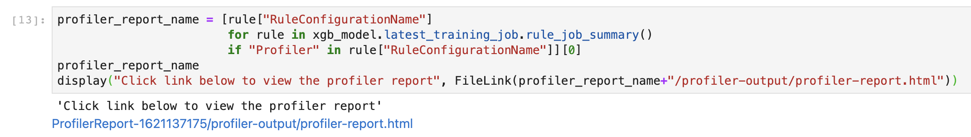

# SageMaker Debugger Profiling Report

SageMaker Debugger auto generated this report. You can generate similar reports on all supported training jobs. The report provides summary of training job, system resource usage statistics, framework metrics, rules summary, and detailed analysis from each rule. The graphs and tables are interactive.

**Legal disclaimer:** This report and any recommendations are provided for informational purposes only and are not definitive. You are responsible for making your own independent assessment of the information.

## Training job summary

## System usage statistics

## Framework metrics summary

## Rules summary

The following table shows a profiling summary of the Debugger built-in rules. The table is sorted by the rules that triggered the most frequently. During your training job, the CPUBottleneck rule was the most frequently triggered. It processed 183 datapoints and was triggered 0 times.

|  | **Description** | **Recommendation** | **Number of times rule triggered** | **Number of datapoints** | **Rule parameters** |
| --- | --- | --- | --- | --- | --- |
| **CPUBottleneck** | Checks if the CPU utilization is high and the GPU utilization is low. It might indicate CPU bottlenecks, where the GPUs are waiting for data to arrive from the CPUs. The rule evaluates the CPU and GPU utilization rates, and triggers the issue if the time spent on the CPU bottlenecks exceeds a threshold percent of the total training time. The default threshold is 50 percent. | Consider increasing the number of data loaders or applying data pre-fetching. | 0 | 183 | threshold:50 cpu_threshold:90 gpu_threshold:10 patience:1000 |
| **IOBottleneck** | Checks if the data I/O wait time is high and the GPU utilization is low. It might indicate IO bottlenecks where GPU is waiting for data to arrive from storage. The rule evaluates the I/O and GPU utilization rates and triggers the issue if the time spent on the IO bottlenecks exceeds a threshold percent of the total training time. The default threshold is 50 percent. | Pre-fetch data or choose different file formats, such as binary formats that improve I/O performance. | 0 | 183 | threshold:50 io_threshold:50 gpu_threshold:10 patience:1000 |
| **Dataloader** | Checks how many data loaders are running in parallel and whether the total number is equal the number of available CPU cores. The rule triggers if number is much smaller or larger than the number of available cores. If too small, it might lead to low GPU utilization. If too large, it might impact other compute intensive operations on CPU. | Change the number of data loader processes. | 0 | 0 | min_threshold:70 max_threshold:200 |
| **BatchSize** | Checks if GPUs are underutilized because the batch size is too small. To detect this problem, the rule analyzes the average GPU memory footprint, the CPU and the GPU utilization. | The batch size is too small, and GPUs are underutilized. Consider running on a smaller instance type or increasing the batch size. | 0 | 179 | cpu_threshold_p95:70 gpu_threshold_p95:70 gpu_memory_threshold_p95:70 patience:1000 window:500 |
| **LoadBalancing** | Detects workload balancing issues across GPUs. Workload imbalance can occur in training jobs with data parallelism. The gradients are accumulated on a primary GPU, and this GPU might be overused with regard to other GPUs, resulting in reducing the efficiency of data parallelization. | Choose a different distributed training strategy or a different distributed training framework. | 0 | 0 | threshold:0.2 patience:1000 |
| **GPUMemoryIncrease** | Measures the average GPU memory footprint and triggers if there is a large increase. | Choose a larger instance type with more memory if footprint is close to maximum available memory. | 0 | 0 | increase:5 patience:1000 window:10 |
| **LowGPUUtilization** | Checks if the GPU utilization is low or fluctuating. This can happen due to bottlenecks, blocking calls for synchronizations, or a small batch size. | Check if there are bottlenecks, minimize blocking calls, change distributed training strategy, or increase the batch size. | 0 | 0 | threshold_p95:70 threshold_p5:10 window:500 patience:1000 |
| **StepOutlier** | Detects outliers in step duration. The step duration for forward and backward pass should be roughly the same throughout the training. If there are significant outliers, it may indicate a system stall or bottleneck issues. | Check if there are any bottlenecks (CPU, I/O) correlated to the step outliers. | 0 | 0 | threshold:3 mode:None n_outliers:10 stddev:3 |
| **MaxInitializationTime** | Checks if the time spent on initialization exceeds a threshold percent of the total training time. The rule waits until the first step of training loop starts. The initialization can take longer if downloading the entire dataset from Amazon S3 in File mode. The default threshold is 20 minutes. | Initialization takes too long. If using File mode, consider switching to Pipe mode in case you are using TensorFlow framework. | 0 | 0 | threshold:20 |

## Analyzing the training loop

### Step duration analysis

### GPU utilization analysis

**Usage per GPU**

**Workload balancing**

### Dataloading analysis

### Batch size

### CPU bottlenecks

### I/O bottlenecks

### GPU memory[¶](https://test-notebook-instance-ts2i.notebook.us-west-2.sagemaker.aws/files/ProfilerReport-1621137175/profiler-output/profiler-report.html?_xsrf=xsrf-token-set-by-sagemaker-1621137846642#GPU-memory)



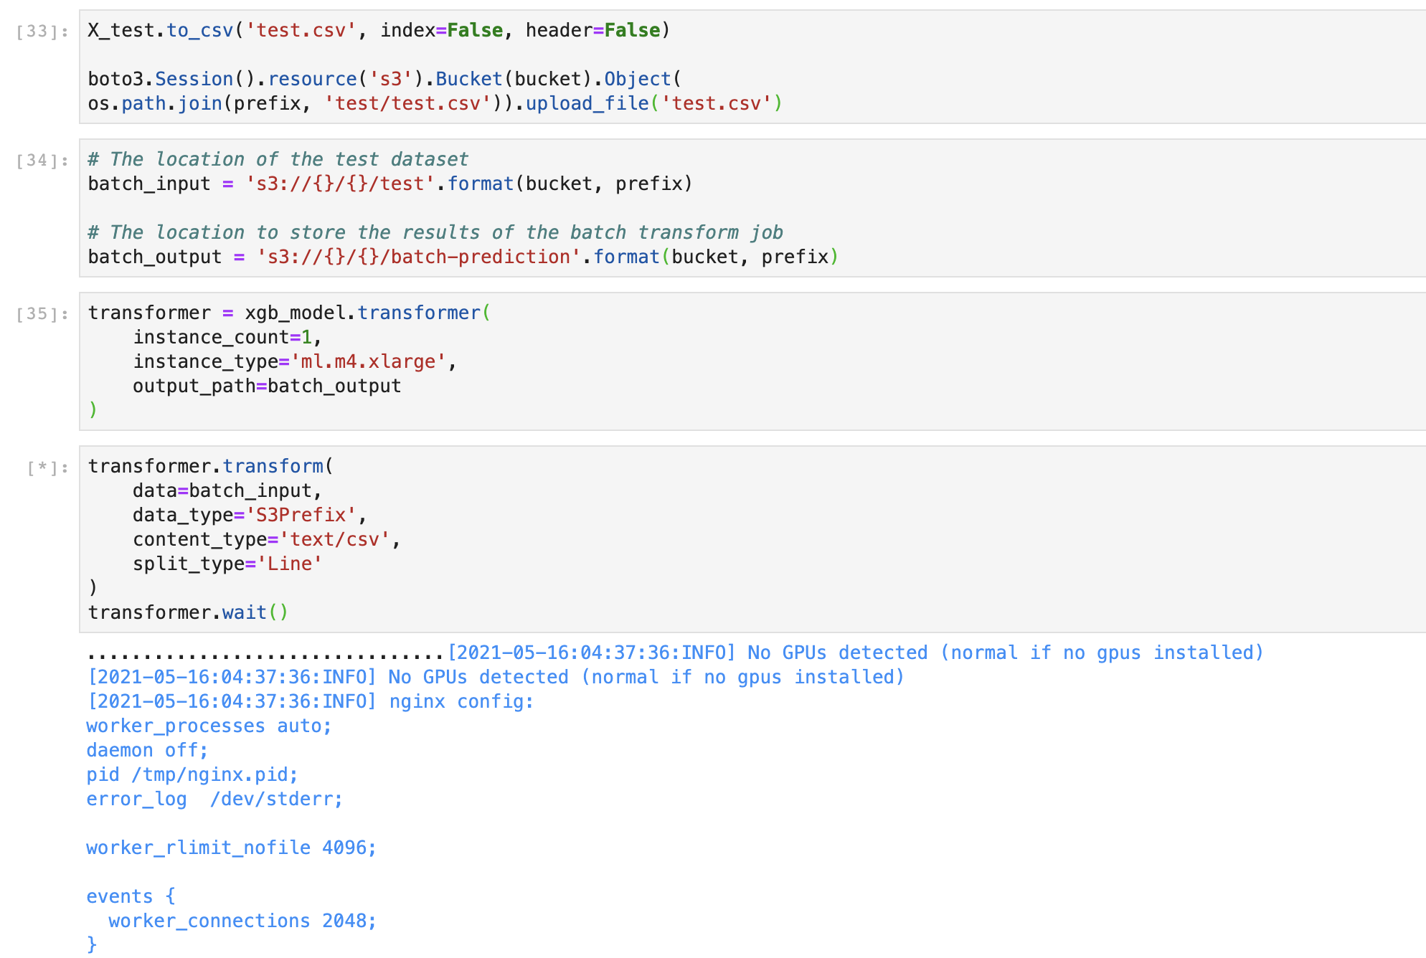

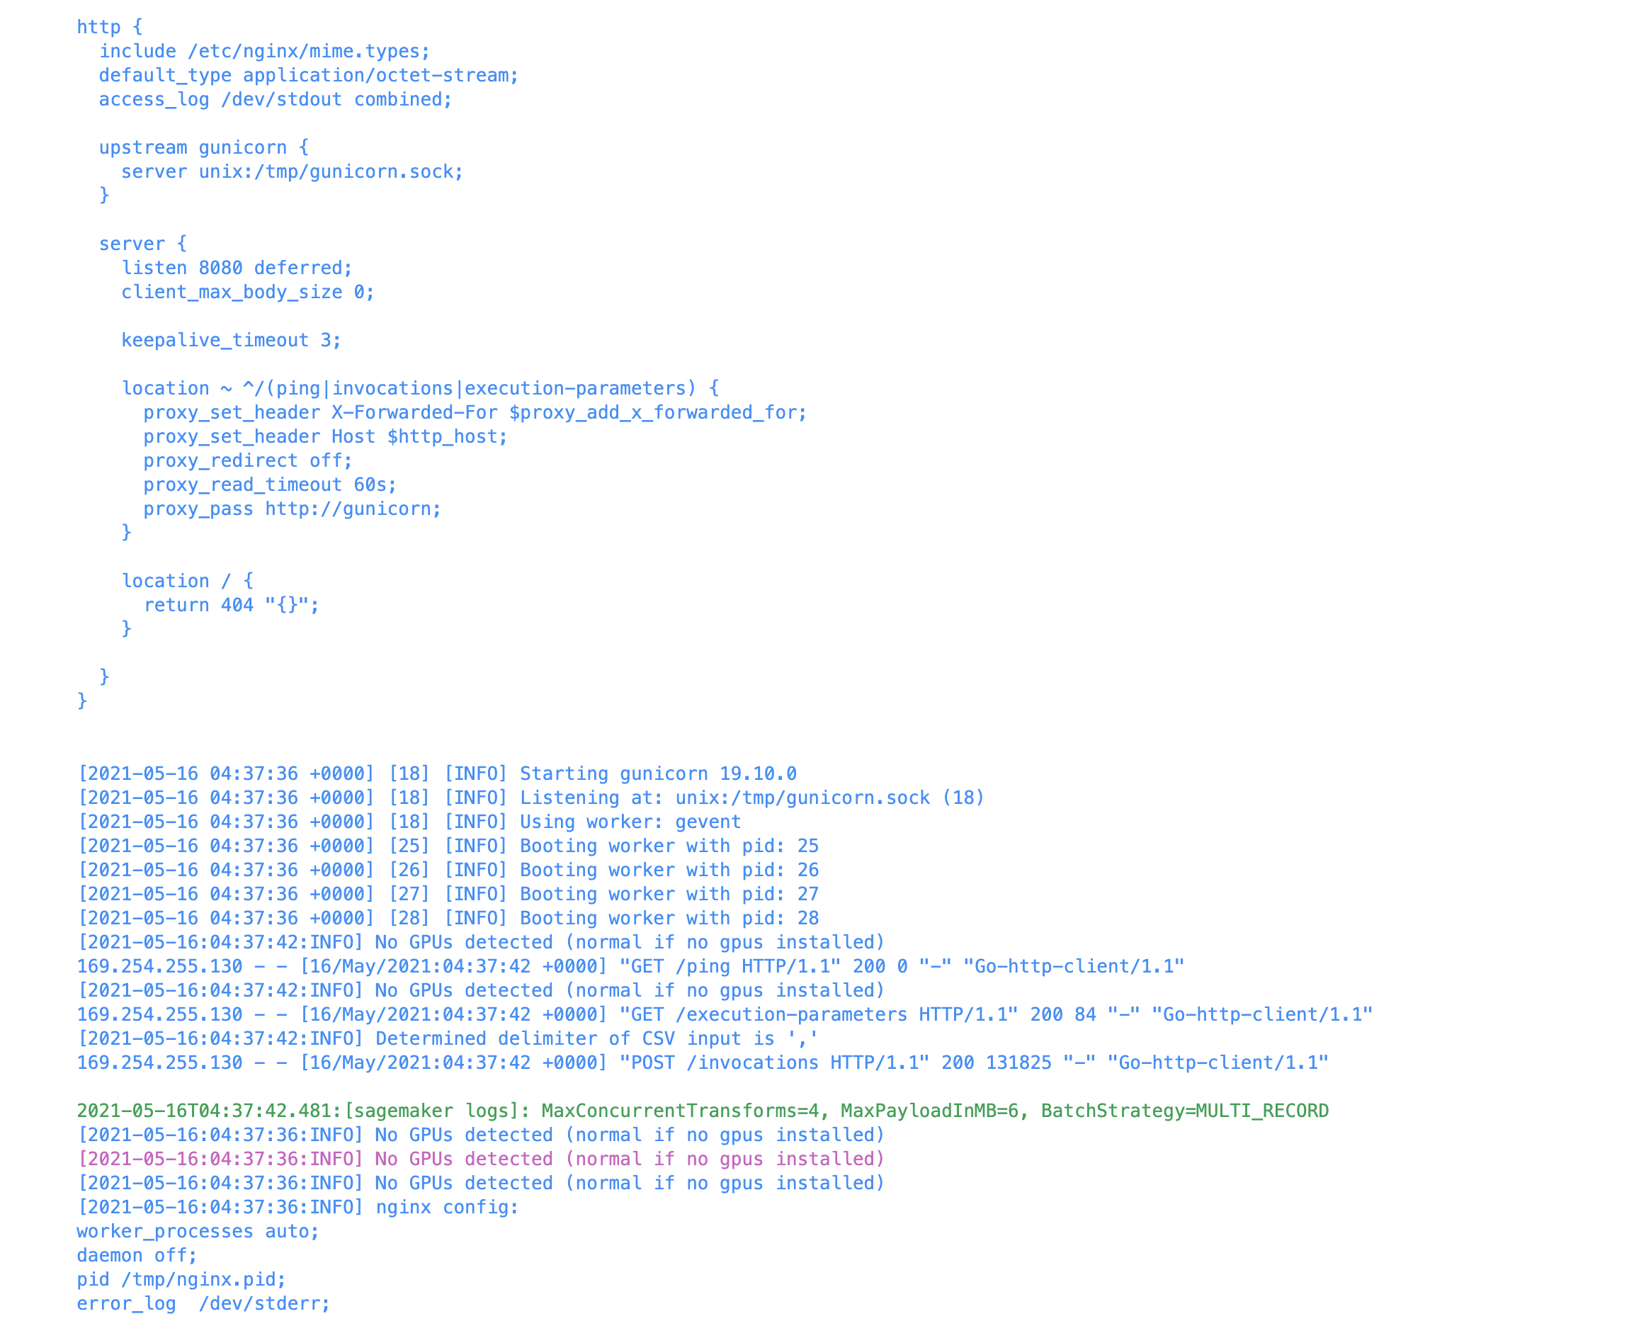

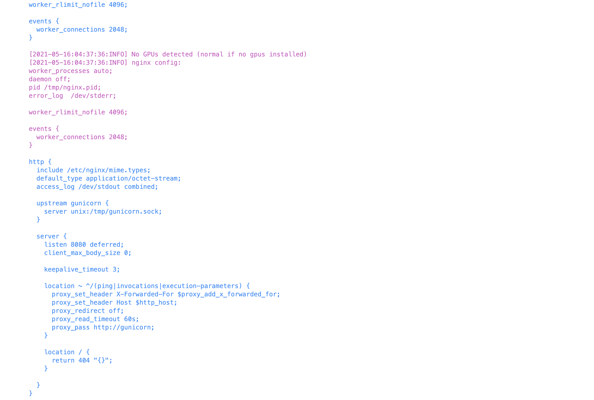

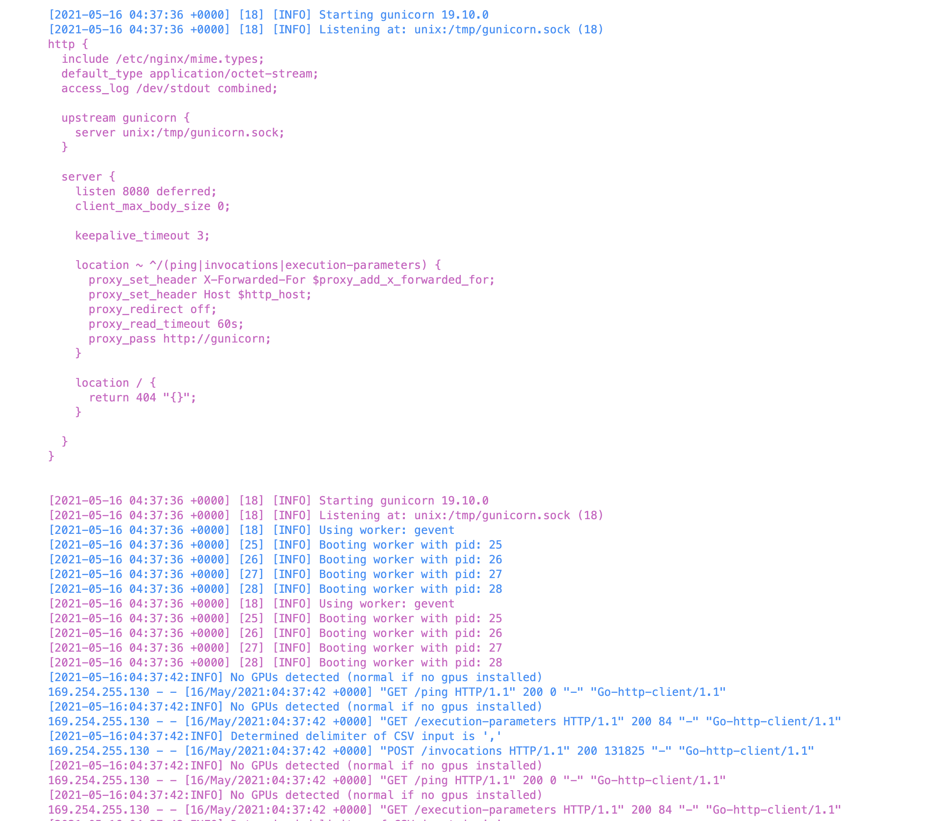

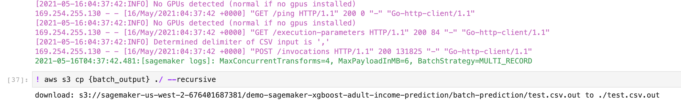

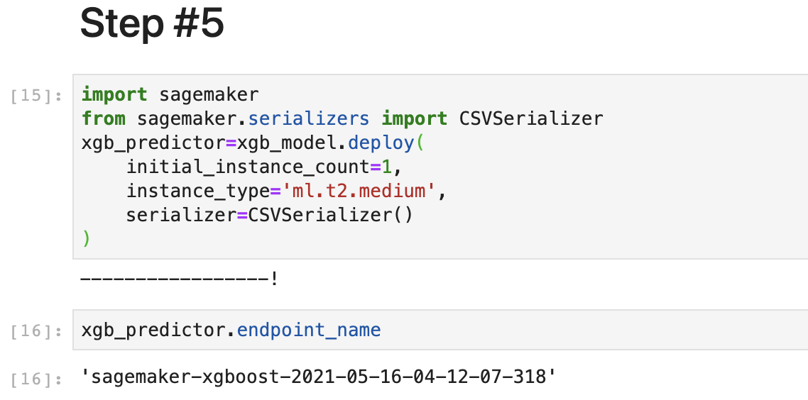

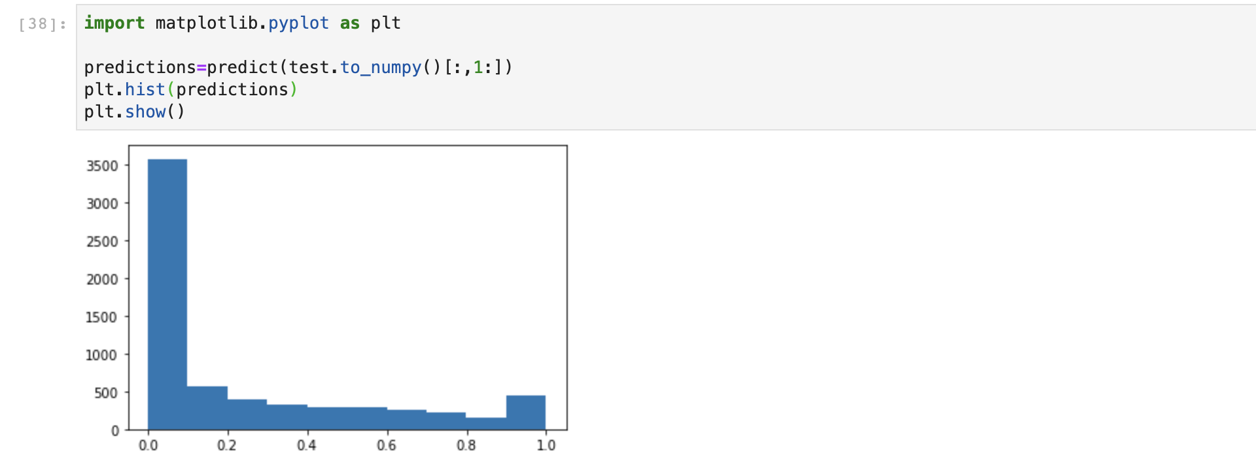

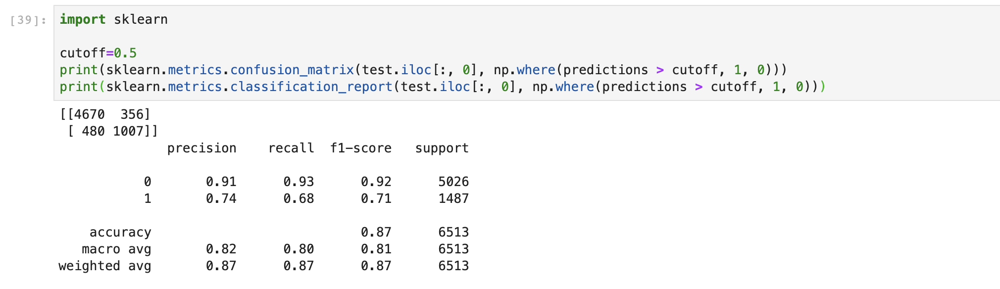

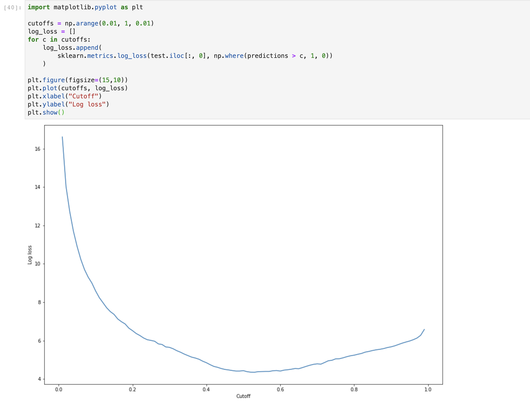

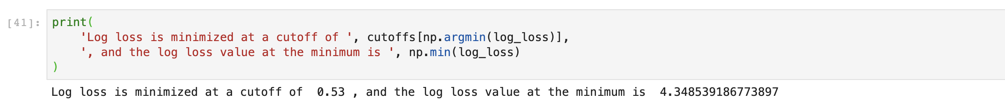

**Step #7**

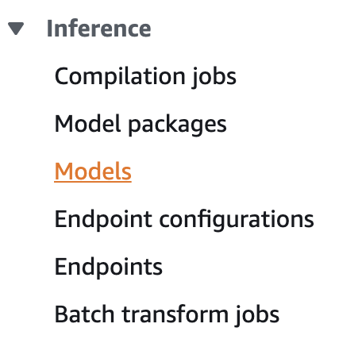

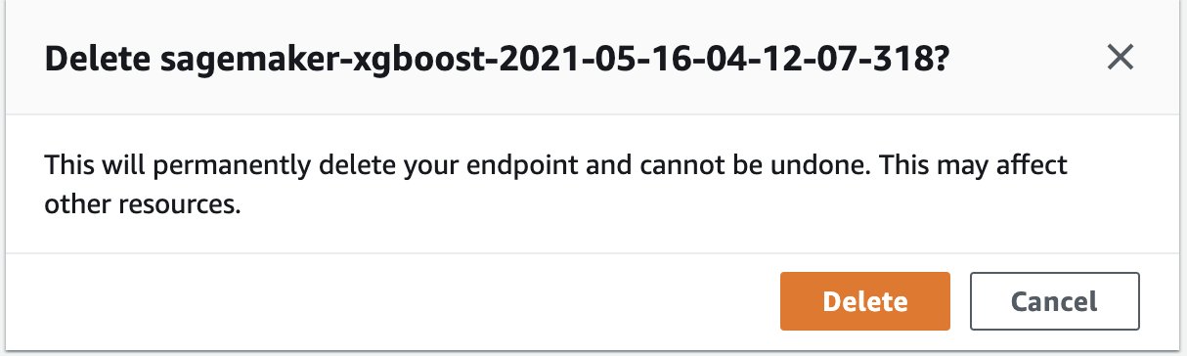

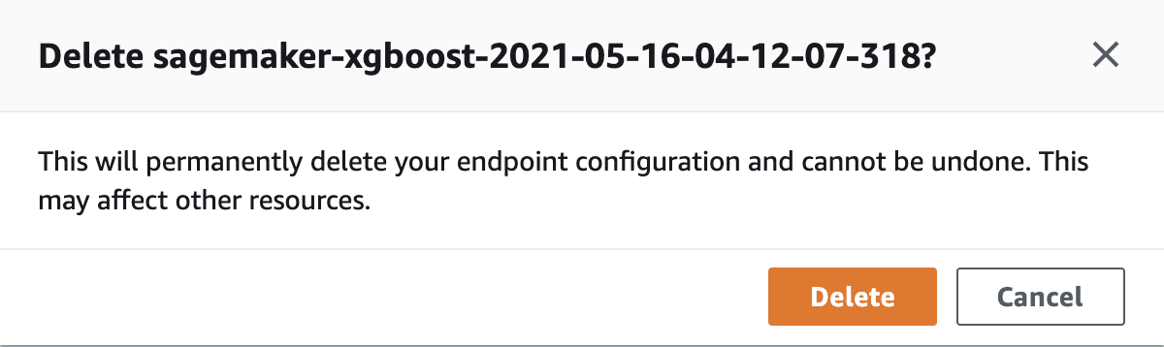

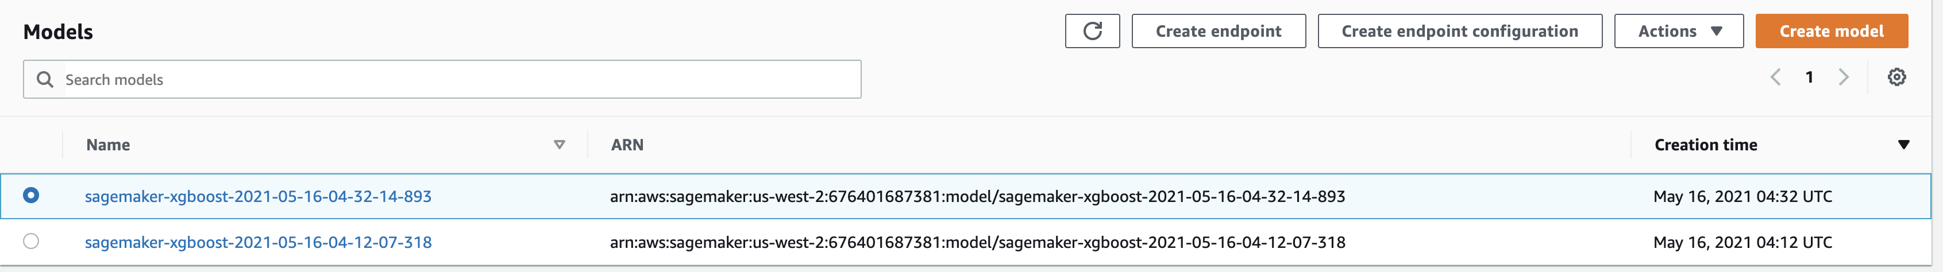

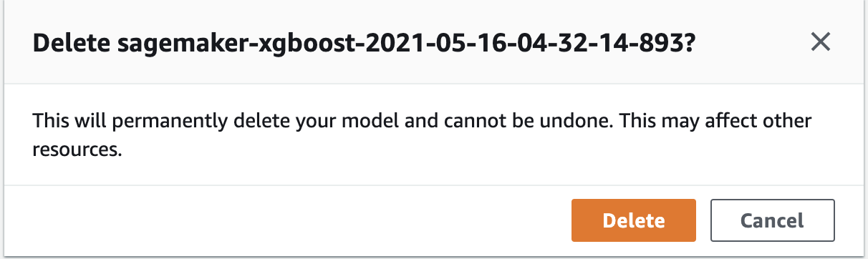

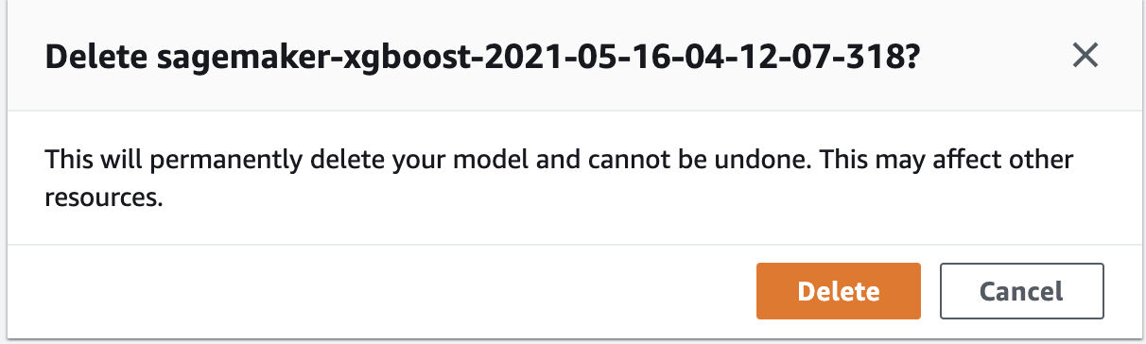

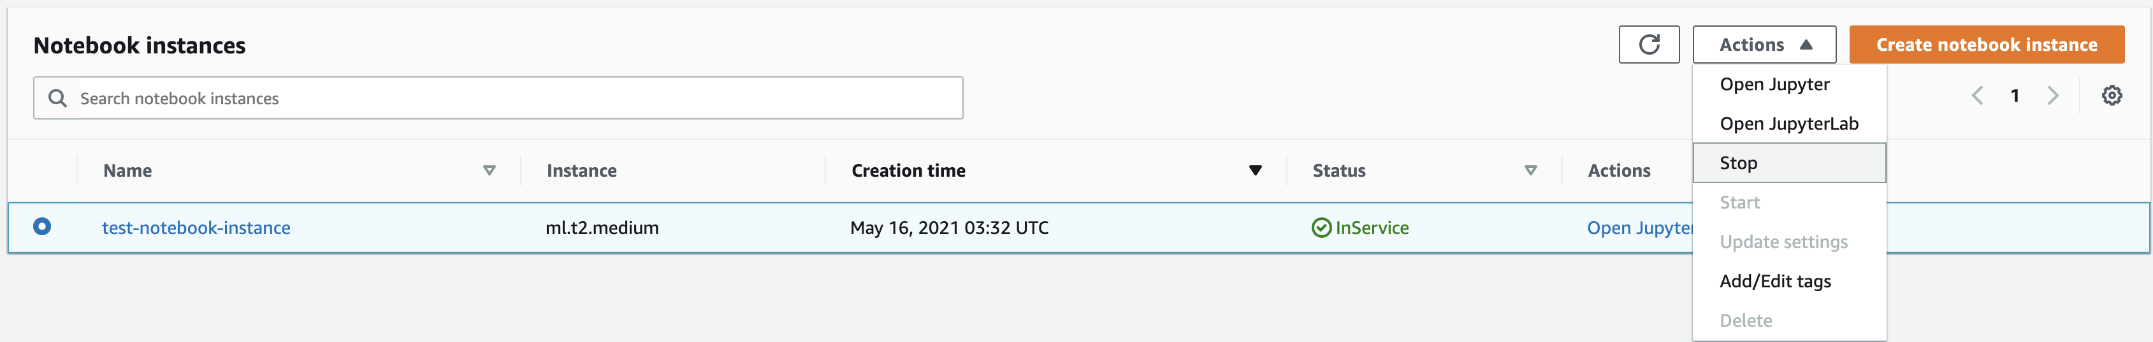

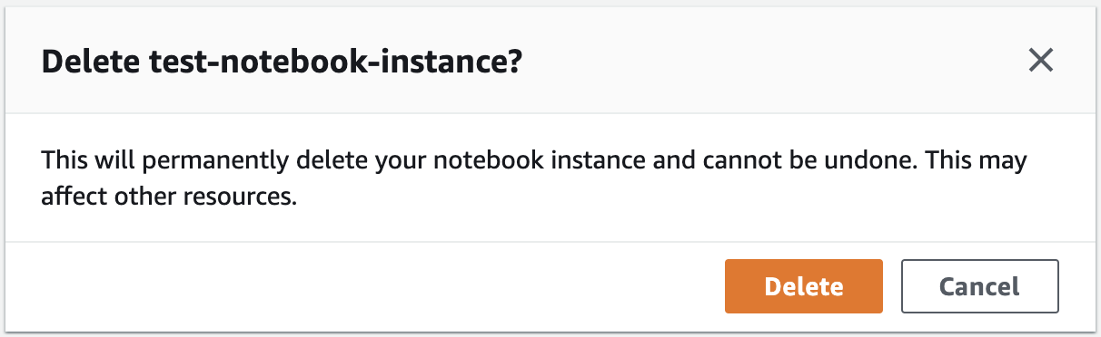

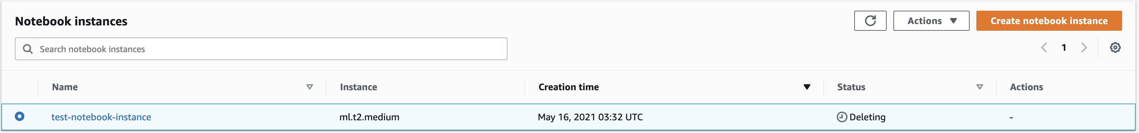

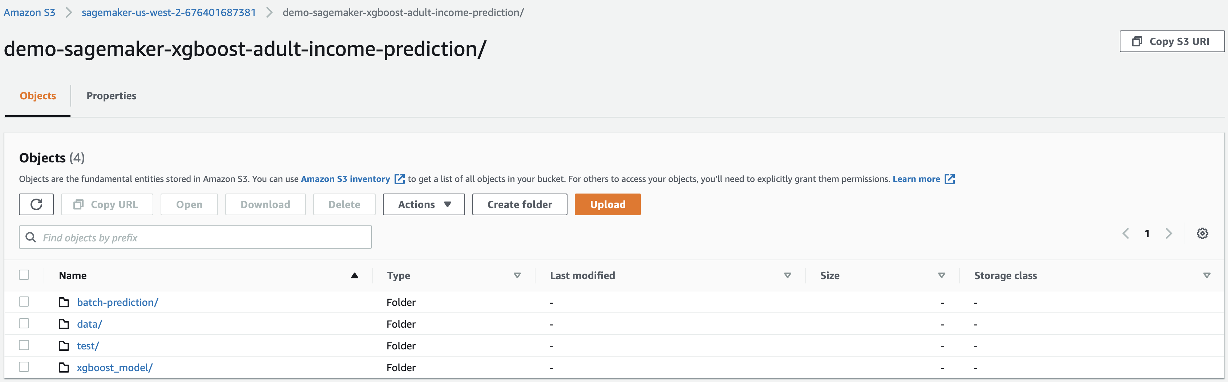

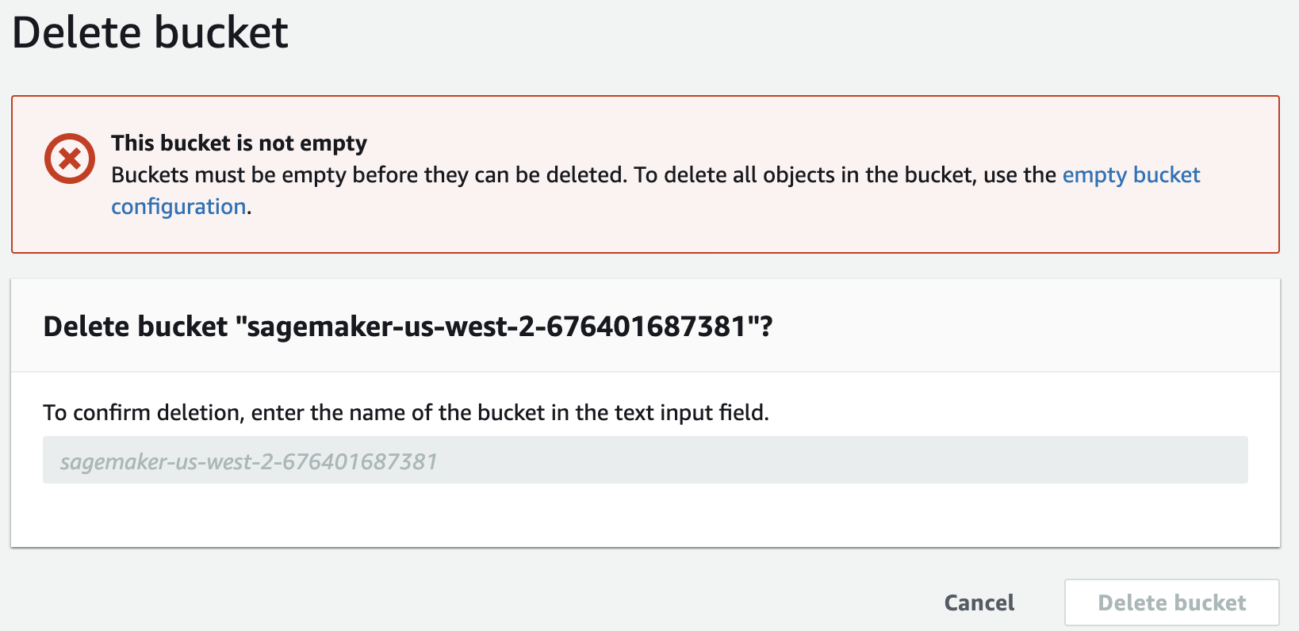

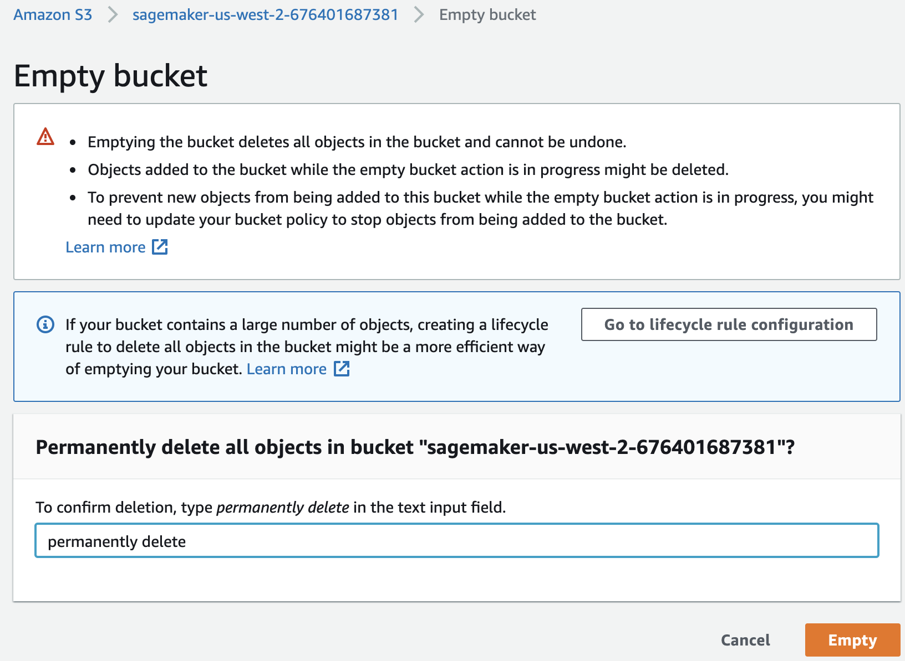

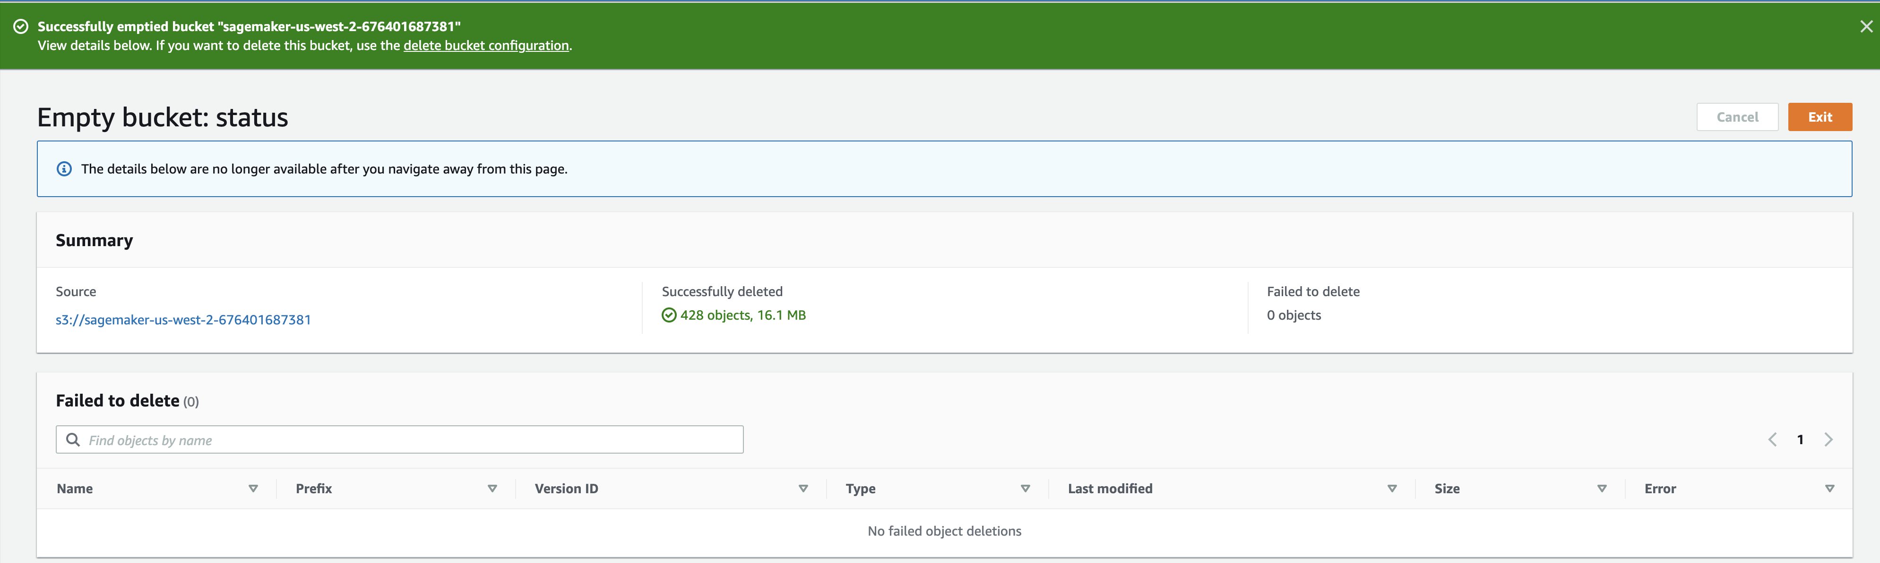

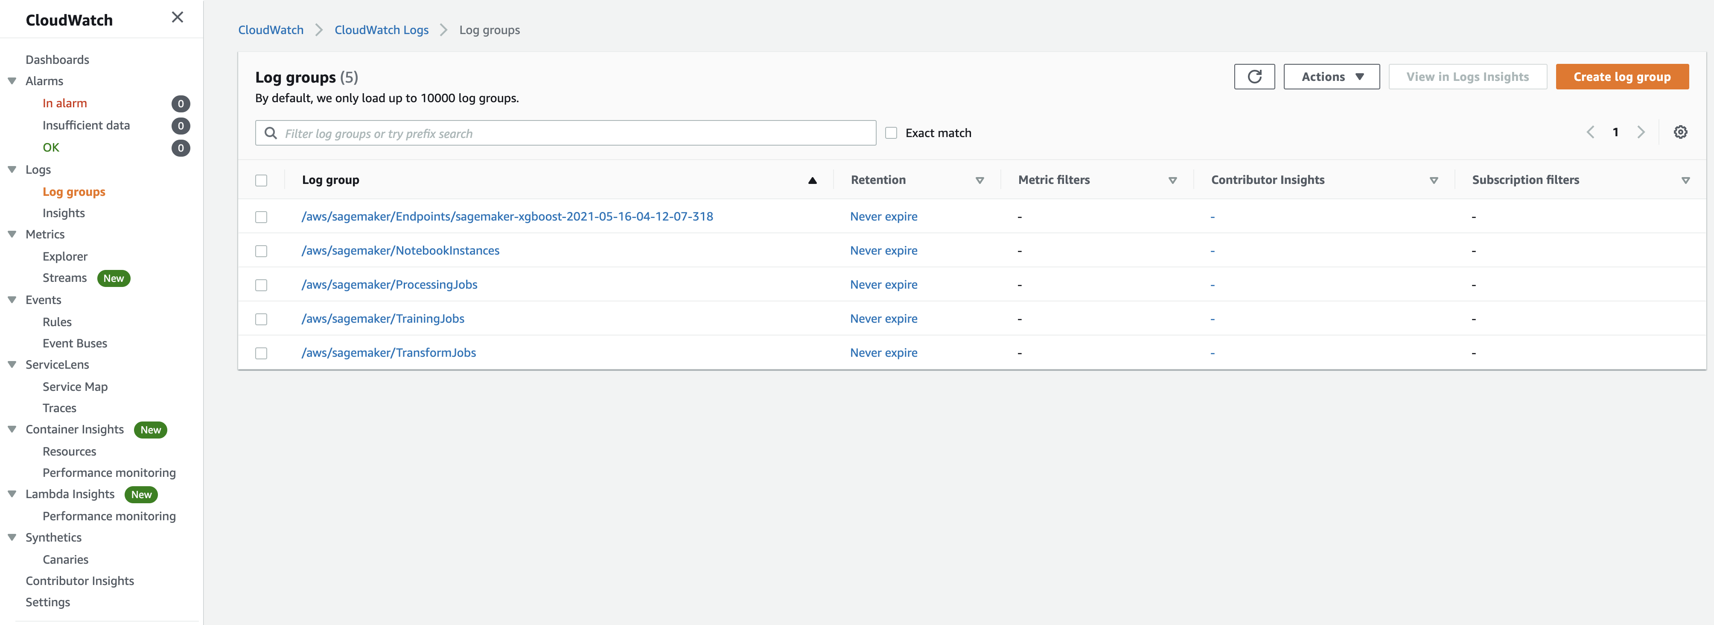

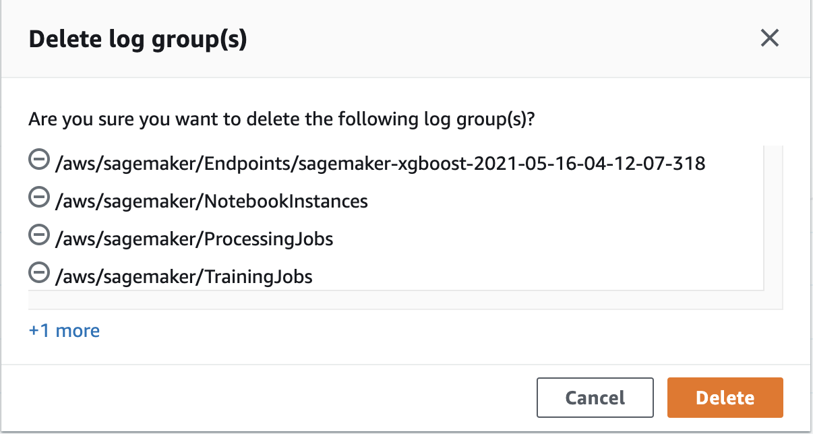

**PART#3**



[

{

"az": "eu-west-1b",

"price": "0.030200"

},

{

"az": "eu-west-1a",

"price": "0.030200"

},

{

"az": "eu-west-1c",

"price": "0.030200"

}

]

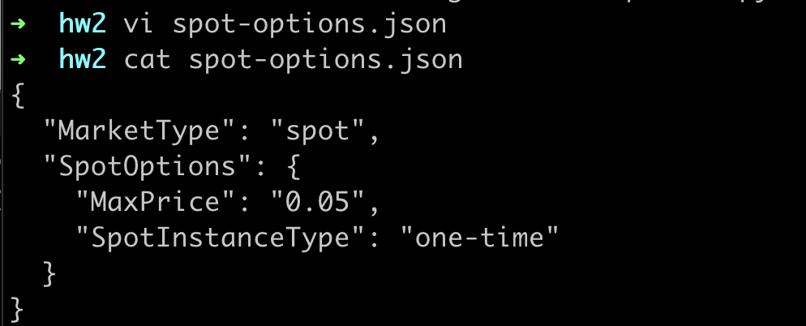

aws ec2 run-instances --image-id ami-0013ea6a76d3b8874 --instance-type t2.micro --security-group-ids sg-010edb7d342290ec4 --associate-public-ip-address --instance-market-options file://spot-options.json --key-name w251

{

"Groups": [],

"Instances": [

{

"AmiLaunchIndex": 0,

"ImageId": "ami-0013ea6a76d3b8874",

"InstanceId": "i-033e61f36d3fa0cb3",

"InstanceType": "t2.micro",

"KeyName": "w251",

"LaunchTime": "2021-05-16T05:19:44+00:00",

"Monitoring": {

"State": "disabled"

},

"Placement": {

"AvailabilityZone": "us-west-2a",

"GroupName": "",

"Tenancy": "default"

},

"PrivateDnsName": "ip-172-31-20-221.us-west-2.compute.internal",

"PrivateIpAddress": "172.31.20.221",

"ProductCodes": [],

"PublicDnsName": "",

"State": {

"Code": 0,

"Name": "pending"

},

"StateTransitionReason": "",

"SubnetId": "subnet-f6981f8e",

"VpcId": "vpc-2e321856",

"Architecture": "x86_64",

"BlockDeviceMappings": [],

"ClientToken": "c6b793c1-a76e-4c93-8fbe-8ca1e0db0c71",

"EbsOptimized": false,

"EnaSupport": true,

"Hypervisor": "xen",

"InstanceLifecycle": "spot",

"NetworkInterfaces": [

{

"Attachment": {

"AttachTime": "2021-05-16T05:19:44+00:00",

"AttachmentId": "eni-attach-0520285498000236d",

"DeleteOnTermination": true,

"DeviceIndex": 0,

"Status": "attaching",

"NetworkCardIndex": 0

},

"Description": "",

"Groups": [

{

"GroupName": "PublicSG",

"GroupId": "sg-010edb7d342290ec4"

}

],

"Ipv6Addresses": [],

"MacAddress": "02:7f:4a:50:f1:17",

"NetworkInterfaceId": "eni-0cd6faf838a10bd6d",

"OwnerId": "676401687381",

"PrivateDnsName": "ip-172-31-20-221.us-west-2.compute.internal",

"PrivateIpAddress": "172.31.20.221",

"PrivateIpAddresses": [

{

"Primary": true,

"PrivateDnsName": "ip-172-31-20-221.us-west-2.compute.internal",

"PrivateIpAddress": "172.31.20.221"

}

],

"SourceDestCheck": true,

"Status": "in-use",

"SubnetId": "subnet-f6981f8e",

"VpcId": "vpc-2e321856",

"InterfaceType": "interface"

}

],

"RootDeviceName": "/dev/sda1",

"RootDeviceType": "ebs",

"SecurityGroups": [

{

"GroupName": "PublicSG",

"GroupId": "sg-010edb7d342290ec4"

}

],

"SourceDestCheck": true,

"SpotInstanceRequestId": "sir-64tgb2fm",

"StateReason": {

"Code": "pending",

"Message": "pending"

},

"VirtualizationType": "hvm",

"CpuOptions": {

"CoreCount": 1,

"ThreadsPerCore": 1

},

"CapacityReservationSpecification": {

"CapacityReservationPreference": "open"

},

"MetadataOptions": {

"State": "pending",

"HttpTokens": "optional",

"HttpPutResponseHopLimit": 1,

"HttpEndpoint": "enabled"

},

"EnclaveOptions": {

"Enabled": false

}

}

],

"OwnerId": "676401687381",

"ReservationId": "r-01dc43f935bc8fa5a"

}

